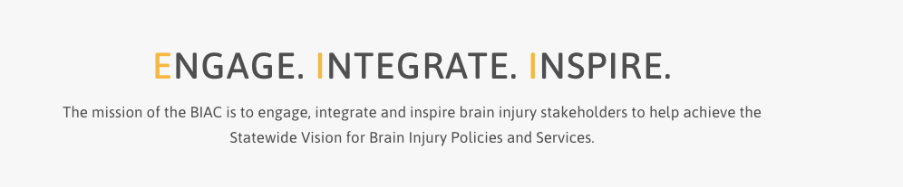

Brain Injury Advisory Council (BIAC) Meeting

September 10, 2021 - 10:00 a.m. - 12:00 p.m. CT

AGENDA

10:00 am: *Call the meeting to order – Roll Call and Introductions– Judy Nichelson

* Approve June 11, 2021 meeting minutes and September 10, 2021 meeting agenda – Judy Nichelson

* Open meeting announcement and public comment, if any – Judy Nichelson

* Peer Support Pilot update (no-cost extension) – Keri Bennett and Emaly Ball

* New TBI Grant Projects, and Opportunities for BIAC Leadership and Involvement – Keri Bennett

* New Business

12:00 pm: Adjourn

Next meeting: December 10, 2021

