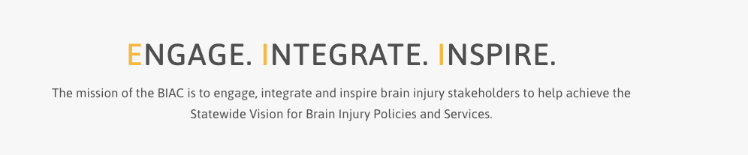

Brain Injury Advisory Council (BIAC) Meeting

June 11, 2021 - 10:00 a.m. - 12:30 p.m. CT

AGENDA

10:00 am: *Call the meeting to order – Roll Call and Introduce new BIAC members; Rhonda Alcorn, Tamara Snider, Michelle Ploeger – Judy Nichelson

* Approve March 12, 2021 meeting minutes and June 11, 2021 meeting agenda – Judy Nichelson

* Open meeting announcement and public comment, if any – Judy Nichelson

* Brain Injury Regional School Support Teams (BIRSST) – Jo Gunderson

* BIA-NE update on programs, services, and supports – Peggy Reisher

* Break, 5 minutes

* Committee Reports:
Membership
Public Policy
Network Capacity Building

* Peer to Peer Support Pilot update – Emaly Ball

* BI Trust Fund update – Peggy Reisher

* Break, 5 minutes

* ACL Federal TBI Program updates – Keri Bennett

* New Business

12:30 pm: Adjourn

Next meeting: September 10, 2021

