Essential
Instructional
Content for
2020-2021

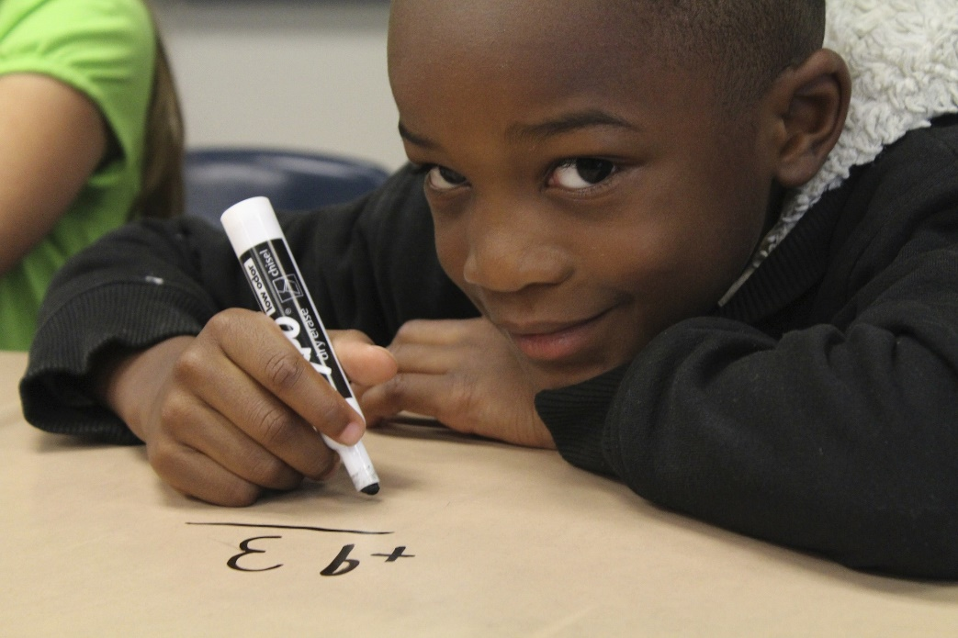
Mathematics
This document has been adapted for use by the Nebraska Department of Education for Nebraska educators. The following guidance contains information about essential Mathematics content for the 2020-2021 school year.

Mathematics
This document has been adapted for use by the Nebraska Department of Education for Nebraska educators. The following guidance (pgs. __-__) contains information about essential Mathematics content for the 2020-2021 school year. To access the English Language Arts/literacy guidance (pgs. __-__), please visit (link here).

This guidance document is advisory in nature but binding on an agency until amended by such agency. A guidance document does not include internal procedural documents that only affect the internal operations of the agency and does not impose additional requirements or penalties on regulated parties or include confidential information or rules and regulations made in accordance with the Administrative Procedure Act. If you believe that this guidance document imposes additional requirements or penalties on regulated parties, you may request a review of the document. For comments regarding these documents contact nde.guidance@nebraska.gov.

NOTE: The Nebraska version of this document was customized from a resource developed by Student Achievement Partners (SAP). The original document, 2020-2021 Priority Instructional Content in English Language Arts/Literacy and Mathematics, is located here. SAP offers acknowledgements to Dr. Robin Hall, Dr. Ricki Price-Baugh, and Denise M. Walston of the Council of the Great City Schools; Phil Daro, Senior Advisor to Student Achievement Partners; as well as the teams at the Council of Chief State School Officers, the Education & Society Program at The Aspen Institute, the National Council of Teachers of Mathematics, Schoolkit, Teaching Lab, TNTP, and UnboundEd.

Table of Contents

Important Information for Nebraska Educators 4

Introduction 5

Mathematics Grades Kindergarten through 8

Essential Instructional Content for the 2020-21 School Year 9

Kindergarten 15

Grade 1 19

Grade 2 25

Grade 3 31

Grade 4 37

Grade 5 43

Grade 6 49

Grade 7 55

Grade 8 60

Appendix 66

Grade band sections have been color-coded throughout this document.
K-1 | 2-3 | 4-5 | 6-8

Important Information for Nebraska Educators

Standards alignment. The authors of this guidance have provided a collection of research that supports the fundamentals of college- and career-ready standards for K-12 students. These standards are designed to best support students in reaching proficiency through a carefully sequenced progression of learning in all content areas. The pre-publication draft of this document was aligned solely to the Common Core State Standards (CCSS) for English Language Arts and Mathematics. In order to best support Nebraska educators, The Nebraska Department of Education’s Office of Teaching, Learning, and Assessment provided an additional crosswalk to Nebraska’s college- and career-ready standards. Please refer to specific content clusters to find information about alignment. Please also note that some elements of CCSS for English Language Arts and Mathematics, for example the articulation of lexile levels across grade bands in ELA standards, are not elements found in Nebraska’s 2014 and 2015 standards, respectively. For questions related to standards alignment between CCSS and Nebraska CCR standards for ELA and Mathematics, please visit Nebraska Department of Education’s Content Area Standards site.

Instructional shifts. The focus and purpose of prioritizing instructional content is to support educators in addressing unfinished learning during the 2020-2021 school year. This document was developed so that educators have the appropriate tools and resources to adjust curricular content. Above all, the intent of prioritizing instructional content is to ensure all students have meaningful opportunities to engage with grade-level work. Likewise, the instructional shifts for ELA and Mathematics provide a roadmap for implementing the standards effectively so that students have equitable access to rigorous, grade-level instruction, texts, assignments, and tasks. When learning standards are revised, important shifts in instruction must occur if the higher expectations represented within them are to be realized. The shifts for ELA and Mathematics describe learning priorities within each content area that coincide with the transition from legacy to college- and career-ready standards. The shifts for ELA and Mathematics should inform practices related to instructional materials, classroom instruction, and assessment. While some of the alignment (see above) provided for use by Nebraska educators contain only broad grade-level standards, certain indicators are also included. Educators are encouraged to consider how and to what extent the instructional shifts are reflected in planned instruction. In addition, consider how to appropriately “cluster” standards rather than attend to them individually or in isolation, thus allowing for richer learning experiences within a lesson or unit of study. Additional information about Nebraska’s College- and Career-Ready Standards Instructional Shifts for ELA, Mathematics, and Science can be found here.

Introduction

What is this guidance?

Based on research and the progression of the disciplines, the 2020–21 Essential Instructional Content names the priorities in mathematics (K–8) and ELA/literacy (K–12) that should be the focus of instruction for educators in the 2020–21 academic year. This document provides guidance for the field about content priorities by leveraging the structure and emphases of college- and career-ready mathematics and ELA/literacy standards. It is intended to help publishers, other designers of instructional materials, and instructional leaders find new efficiencies in the curriculum that are critical for the unique challenges that have resulted from school closures and anticipated disruptions in the year ahead, keeping at the forefront principles of equitable instruction that support all students.

Why create this guidance?

The 2020–21 school year presents a unique set of opportunities and challenges due to the disruption to instruction in spring 2020 as well as the uncertainty associated with what the “return to school” will look like. Educators know that every school year there are students who require support in addressing unfinished learning from prior grades, a challenge that will be felt more prominently in the 2020–21 school year. Most critically, the pandemic has further illuminated inequities that have always existed. Rich, engaging instruction at grade level has typically not been offered to students of color, students experiencing poverty, and emerging bilingual students. Our position is that it is entirely possible to hold high expectations for all students, address unfinished learning in the context of grade-level work, and dial into the assets students bring with them in order to unlock the creativity and energy they bring to the joyful work of learning something new. Since time is a scarce commodity in classrooms—made more limited by anticipated closures and distance or hybrid learning models in the fall of 2020—strategic instructional choices about which content to prioritize, and what and how to assess, must be made.

This guidance names the content that should be of focus for all students, recognizing that intentional instructional choices will be essential for supporting all students to mastery, and that this is especially true for students with specialized learning needs. This document does not address the many considerations of instruction, but recognizes that it is critical for those using the guidance and supporting English learners to ensure that students have the instructional supports and scaffolds that supplement, and do not supplant, core instruction and thereby ensure students’ access to grade-level content. As emphasized by the Council of the Great City Schools in Addressing Unfinished Learning After COVID-19 School Closures, "Teachers should therefore resist the inclination to ‘water down’ instruction and assignments for ELL students—and other students with specialized learning needs. These students require the same challenging work and cognitive demands as their peers in order to develop academic skills and grow as scholars."¹ Note that for English learners, language and content development are simultaneous and should be considered in context of math and literacy instruction. For more specific guidance about adjusting curricular content to meet the needs of English learners, please see the resources created by the English Learner Success Forum including activities and scaffolds that can be strategically built into lessons and units to deepen and accelerate English learners’ content area learning in mathematics and ELA/literacy.² Please also see the frameworks from the Council of the Great City Schools for Re-envisioning Mathematics Instruction and Re-envisioning English Language Arts and English Language Development for detailed curricular and instructional guidance for English learners.3

How should assessment be considered in light of this instructional guidance?

Uncovering and addressing unfinished learning in the context of grade-level work will require teachers to know what students know and can do throughout the school year. This document is not intended to serve as a guide for development of assessment products. However, the instructional guidance has implications for assessment in service of equitable grade-level instruction. Assessment should:

- Be used to determine how to bring students into grade-level instruction, not whether to bring them into it.

- Center formative practices.4 Leverage such sources of information as exit tickets, student work, and student discussions. Use these sources of information to inform instructional choices in connection with high-quality instructional materials.

- Employ targeted checks for very specific subject and grade-level instructional purposes (specifically, phonics or math fluency inventories, checks for reading fluency).

This approach is being proposed as a deliberate alternative to assessment choices that have the potential to serve as a gatekeeper to grade-level content. It also deliberately recognizes the very real social-emotional needs of students—particularly students who have been disproportionately affected by the pandemic. After such major disruptions, it is essential that students engage, immediately and consistently, in the affirmative act of learning new ideas, not be deemed deficient because of events outside of their control. Regarding
administering tests too soon, the Council of the Great City Schools notes in Addressing Unfinished Learning After COVID-19 School Closures that “testing appears to put the onus of learning losses on the students themselves—the resulting label of ‘deficient’ or academically behind may very well further alienate and isolate the students who most need our support.”5

2 https://www.elsuccessforum.org/resources
3 https://www.cgcs.org/Page/664
4 https://ccsso.org/sites/default/files/2018-06/Revising%20the%20Definition%20of%20Formative%20Assessment.pdf
5 Council of the Great City Schools, 2020

What is the purpose of this guidance?

The intention of this guidance is to inform and influence the decisions of the following:

  - Publishers of instructional materials: to design modifications to mathematics and ELA/literacy instructional materials for the 2020–21 school year.

  - District mathematics and ELA/literacy leaders: to design modifications to scope and sequence documents, to design professional learning scope and sequence for teachers, to design modifications to district-created instructional materials where used, and to support administrators in implementing equitable instruction and equitable structures.

  - State education agencies: to support districts in planning and decision-making for instruction.

  - Providers of professional learning for teachers: to design modifications to professional learning curricula for the summer of 2020 and the 2020–21 school year.

This guidance has been developed in response to current conditions. These documents are not criteria, and they do not revise college- and career-ready state standards. This guidance does not stand alone but is to be used in conjunction with those standards. This guidance does not attempt to repeat what standards already say, nor does it mention every opportunity the standards afford to make coherent connections within a grade or between one grade and another. Further, leveraging the focus and coherence of high-quality instructional materials aligned to college- and career-ready state standards is more important than ever.

This guidance was developed with additional principles specific to current needs:

  - Generalizability and usability. The recommendations should allow a variety of decision makers to implement valuable changes to instructional materials and instructional planning.

  - Flexibility. The 2020–21 school year is uncertain in terms of what schooling looks like; therefore, guidance should not specify pedagogy or make assumptions that learning is happening in physical classrooms with a designated content teacher.

  - Social, emotional, academic considerations. While this guidance does not address the many considerations of instruction in full, the grade-band and grade-level considerations include practical ideas for attending to students' social-emotional development in the context of teaching the academic content described. Emotional health and well-being of students is a

central concern of educators, particularly given the pandemic, and these suggestions demonstrate ways in which social, emotional, and academic development can be fostered in the context of grade-level college- and career-ready content. These suggestions have been informed by Supporting Social, Emotional, & Academic Development: Research Implications for Educators from the University of Chicago Consortium on School Research.

This guide is intended to complement resources being released by the Nebraska Department of Education to address the challenges of prioritizing instruction and addressing unfinished learning and the social-emotional and mental health needs of students. The common messages found across these materials illustrate a consensus in the field around the importance of safeguarding equity and access in the wake of the COVID-19 crisis.

Essential Instructional Content for 2020-2021: Mathematics
As the 2020–2021 school year approaches, mathematics educators are more interested than ever in knowing which topics or standards are most important. This document provides guidance for the field about content priorities by leveraging the structure and emphases of
college- and career-ready mathematics standards. As in previous years, students will need to engage deeply with grade-level mathematics by justifying claims, sharing their thinking and responding to the thinking of others, and solving well-chosen problems that connect to their world and advance them mathematically. As noted in Catalyzing Change in Middle School Mathematics: Initiating Critical Conversations (NCTM, 2020b), “[T]here still remains a considerable need for a more consistent, systematic, and widespread implementation of college and career readiness standards in the ways in which they were intended.”

That observation isn’t specific to the current moment. What is new, given the recent and ongoing interruptions to schooling, and given widespread moves to remote or hybrid learning, is a set of conditions that threaten to make good math instruction seem a luxury we can’t afford. Because of these factors, and because of greater than usual variability in the recent mathematics experiences of returning students, educators will be looking for ways to accelerate learning and “catch up.” But students are unlikely to benefit from simply increasing the pace. Indeed, in guidance from the Council of the Great City Schools, Addressing Unfinished Learning After COVID-19 School Closures (CGCS, 2020), a key recommendation is to

Focus on the depth of instruction, not on the pace… [A]void the temptation to rush to cover all of the ‘gaps’ in learning from the last school year. The pace required to cover all of this content will mean rushing ahead of many students, leaving them abandoned and discouraged. It will also feed students a steady diet of curricular junk food: shallow engagement with the content, low standards for understanding, and low cognitive demand—all bad learning habits to acquire. Moreover, at a time when social emotional wellbeing, agency, and engagement are more important than ever, instructional haste may eclipse the patient work of building academic character and motivation.

But where will the time for in-depth teaching come from? The specific grade-level guidance in this document is intended to help publishers, other designers of instructional materials, and mathematics instructional leaders find new efficiencies in the curriculum that are critical for the unique challenges that have resulted from school closures and anticipated disruptions in the year ahead. In the grade-level sections that follow, the most important priorities in each grade are clearly signaled. Opportunities are highlighted for combining lessons about topics. If
7 The structure of this document could be emulated for high school mathematics courses. In addition, resources about developing pathways in high school mathematics are provided in the Appendix (see Charles A. Dana Center, 2019; Daro & Asturias, 2019; National Council of Teachers of Mathematics, 2018).

some material from the grade must be omitted entirely or almost entirely, then the possibilities indicated here can help to minimize negative effects on student progress. Recommendations are also made for integrating previous-grade topics within relevant grade-level work. These and other considerations in the grade-level documents can help students engage deeply with grade-level mathematics this year and in subsequent years.

The guidance at each grade level is tied to individual content clusters, or in some cases to individual standards, and this degree of specificity is necessary to support those who work directly with the design of curricula. However, the specifics of clusters or standards mustn’t become trees that obscure the mathematical forest. Two forest-level views are essential. One opens out to a vista of mathematical practices: mathematical content is only learned according to college- and career-ready standards when it is connected to mathematical practices. A second forest-level view opens out to reveal the shape of the mathematical content itself: a focused, coherent arc that traces a student’s journey from arithmetic to algebra. This design is supported by evidence from diverse sources including education research, international comparisons, and national reports.⁸ By preserving both of these forest-level views, educators can maintain the continuity of their mathematical vision during a time of great interruption.
***

As noted in the above quotation from Addressing Unfinished Learning After COVID-19 School Closures (CGCS, 2020), “social emotional wellbeing, agency, identity, and belonging are more important than ever.” Indeed as focus narrows and there is recommitment to what matters most academically, research tells us that four learning mindsets are particularly important in supporting students’ academic development, specifically students’ sense of 1) belonging and safety, 2) efficacy, 3) value for effort and growth, and 4) engagement in work that is relevant and culturally responsive (Aspen Institute, 2019; The University of Chicago Urban Education Institute, 2018). Within classrooms, within schools, attention must be given to restoring relationships and a sense of community, so students feel safe, engage fully, and work hard. Students need help knowing that caring adults believe in them and that their ability and competence will grow with their effort. And more than ever, students need to see value and relevance in what they are learning to their lives and their very beings. Investing in students' social-emotional development is done by the entire system of adults in schools.

This investment is key to promoting engagement in—not a substitute for—teaching academic content. Therefore at each grade level, this document provides recommendations for facilitating students’ social, emotional, and academic development (SEAD) in mathematics. These recommendations stress themes of discourse, belonging, agency, and identity and can either be applied across grades (even if only listed in one) or they can be modified to fit different grades and different learning environments. Note that in mathematics, there is a close connection between social, emotional, and academic development and the Standards of Mathematical Practice; the recommendations reflect

8 Selected research appears in the Appendix.

this connection. When these practices are done well, they not only improve the teaching and learning of mathematics, they can address social-emotional learning as well.

***

Confidence about the coming school year will come not only from recognizing the power and dedication of educators across the country, but also from trusting in the resources of our nation’s students. Our beliefs about our students will matter greatly to our success. In Catalyzing Change in Early Childhood and Elementary School Mathematics: Initiating Critical Conversations (NCTM, 2020a), there is a valuable list of productive and unproductive beliefs about children’s mathematical ability. Three of the productive beliefs are especially relevant today, not only during early childhood and elementary school but also in middle grades (Table M-1).

Table M-1. Selected productive beliefs about children’s mathematical ability from Catalyzing Change in Early Childhood and Elementary School Mathematics: Initiating Critical Conversations (NCTM, 2020a).

Selected Productive Beliefs About Children’s Mathematical Ability from Catalyzing Change in Early Childhood and Elementary School Mathematics: Initiating Critical Conversations (NCTM, 2020a)
Mathematics curriculum and instruction should account for and leverage human difference to promote rich and connected mathematics learning experiences. A common shared mathematics learning experience benefits all children.
All children should have access to grade-level mathematics content centered on learning mathematics with understanding, actively building new knowledge from their informal experiences and prior knowledge.
Interventions must focus on content that is connected with and promotes the grade-level curriculum through problem solving and reasoning and not be a review of low-level basic facts or procedural skills.

Remember that “Children prefer mathematical learning experiences that challenge their thinking and allow them to be creative in solving problems, responding positively to statements, such as, ‘I like complex problems more than easy problems’ and ‘I like activities that challenge my thinking abilities.’…[C]hildren who have regular opportunities to collaborate on challenging tasks, use varied solution approaches, and focus on sense making have higher mathematics achievement” (NCTM, 2020a). Interventions must provide students with

more opportunities, not fewer, to engage deeply with grade-level mathematics in all its dimensions. A virtue of concentrating on grade-level work is that each topic in the grade-level curriculum will reveal the prior understandings and assets of the students in its own way, so that teachers can build on those understandings and assets efficiently to access the topic at hand. This is remediating “just in time,” not “just in case.”

How should mathematics assessment be considered in light of this instructional guidance?

Uncovering and addressing unfinished learning in the context of grade-level work will require teachers to know what students know and can do at the beginning and throughout the school year. This document is not intended to serve as a guide for assessment products. However, the instructional guidance has implications for assessment in service of equitable grade-level instruction. Assessment should:

- Be used to determine how to bring students into a unit of grade-level instruction, not whether to bring them into it.

- Center formative practices (FAST SCASS, 2018). Leverage such sources of information as exit tickets, student work, and student discussions. Use these sources of information to inform instructional choices in connection with high-quality instructional materials.

- Employ targeted checks for very specific subject and grade-level instructional purposes (specifically, math fluency inventories).

In mathematics in particular, assessment will be more useful, efficient, and supportive of social, emotional, and academic development when it takes place at the instructional triangle of teacher, student, and (grade-level) subject. For example, unit-level assessments that publishers provide to accompany high-quality instructional materials are preferable to district-administered interim assessments. In mathematics, we can better understand students’ thinking even on assessments by engaging them in discussions of the problems they worked on.

Assessment should be used to determine how to bring students into a unit of grade-level instruction, not whether to bring them into it. The point isn’t to generate data about what students get right and wrong; it’s to understand how to support students as they work. A single multiple choice item will not provide that, nor will a single numerical score. In mathematics, sometimes a couple of well-selected problems do the job of providing the right information to understand how to support students. In a distance learning scenario, one-on-one check-ins with students are likely the best way to understand how they are thinking about some of the important particulars and to help them understand how those particulars connect to the current grade-level content they are about to engage with.

Pre-assessment is not needed for every unit in a curriculum. In some cases the prerequisites to a unit are few. Indeed some topics are well thought of as making their first appearance in a given grade, and diagnosing about such topics is inappropriate. In many cases, the

prerequisites for a unit are naturally and efficiently prompted by the content of the unit itself (remediating just-in-time, not just-in-case). And in some cases, students’ entry is based on a longer trajectory over multiple years.

This approach is being proposed as a deliberate alternative to assessment choices that have the potential to serve as a gatekeeper to grade-level content. It also deliberately recognizes the very real social-emotional needs of students—particularly students who have been
disproportionately affected by the pandemic. After such major disruptions, it is essential that students engage immediately and consistently in the affirmative act of learning new ideas, not be deemed deficient because of events outside of their control. Regarding administering tests too soon, the Council of the Great City Schools notes in Addressing Unfinished Learning After COVID-19 School Closures that “testing appears to put the onus of learning losses on the students themselves—the resulting label of ‘deficient’ or academically behind may very well further alienate and isolate the students who most need our support” (CGCS, 2020).

***

Mathematics has seldom been as prominent in the public square as it is now. Fewer citizens are saying, “I’m not a math person.” Instead they are reading the news about COVID-19 and contemplating rates, percentages, denominators, and time lags in order to know better how they can safely conduct their lives. Today, mathematics offers students both the empowerment that comes from using mathematical tools to understand and confront an epidemic, as well as the emotional escape that can come from permitting oneself to entertain abstract but beautiful questions at such a time. “Each and every child must be afforded opportunities to not only feel confident as doers of mathematics but also to experience joy and see the beauty in their mathematical discoveries” (NCTM, 2020b). Our students’ resilience is being tested but they have minds eager to learn. Supporting students’ social and emotional needs during these uncertain times cannot be done by rushing through all of the current grade-level mathematics while simultaneously re-teaching prior grade-level content that students might have missed. Rather, now is the time to deliver even more thoughtfully on the promise of deep learning of mathematics, especially that which allows our students to connect the content to their world in meaningful ways.

How This Document Works

The Mathematics Essential Instructional Content for the 2020–21 School Year is designed to support decisions about how to elevate some of the most important mathematics at each grade level in the coming school year while reducing time and intensity for topics that are less integral to the overall coherence of college- and career-ready standards.

At each grade level from kindergarten through grade 8, the content names the grade-level mathematics that is of highest priority at each grade; provide a framework for strategically drawing in prior grade-level content that has been identified as essential for supporting students’ engagement with the most important grade-level work; and suggest ways to reduce or sometimes eliminate topics in a way that minimizes the impact to overall coherence. In using this guidance, decision makers should thoughtfully consider in their unique context the likely implications of the spring 2020 disruption as decisions are made to select supports to ensure that students are able to successfully engage with the grade-level content. Decision makers should also bear in mind that while this document articulates content priorities, elevating the Standards for Mathematical Practice in connection with grade-level content is always a priority.

At each grade level, recommendations are provided for facilitating social, emotional, and academic development (SEAD) in mathematics. These recommendations stress themes of discourse, belonging, agency, and identity and can either be applied across grades (even if only listed in one) or they can be modified to fit different grades. These themes of discourse, belonging, agency, and identity are integral to the Standards of Mathematical Practice and the language in the recommendations reflects this connection.

The 2020–21 school year presents a unique set of opportunities and challenges due to the disruption to instruction in spring 2020 as well as the uncertainty associated with the 2020–2021 school year. The content is provided in response to these conditions. They are not criteria, and they do not revise the standards. Rather, they are potential ways, and not the only ways possible, to help students engage deeply with grade-level mathematics in the 2020–21 school year. The content does not stand alone but are to be used in conjunction with college- and career-ready standards. The content does not reiterate what the standards already say—even in cases where the specific language of a standard is fundamentally important to a high-quality aligned curriculum. Nor does the content mention every opportunity the standards afford to make coherent connections within a grade or between one grade and another—again, even when those connections are fundamentally important and are the basis for the guidance given. Therefore, the content will be used most powerfully in cross-grade collaboration among educators who know the standards well and can use existing resources such as the Progressions documents and other resources listed in the Appendix.

While the grade-level guidance isn’t specific to any math program or set of programs, an examination of a selection of curriculum scope and sequence documents informed the recommendations, especially recommendations about when and how to integrate prior-grade concepts into the current grade. The guidance concentrates the recommendations on the most critical prior-grade connections, with greater emphasis on content which was likely taught during the last third of the 2019–20 school year based on scope and sequence analysis.
Kindergarten Mathematics Essential Instructional Content for 2020-2021

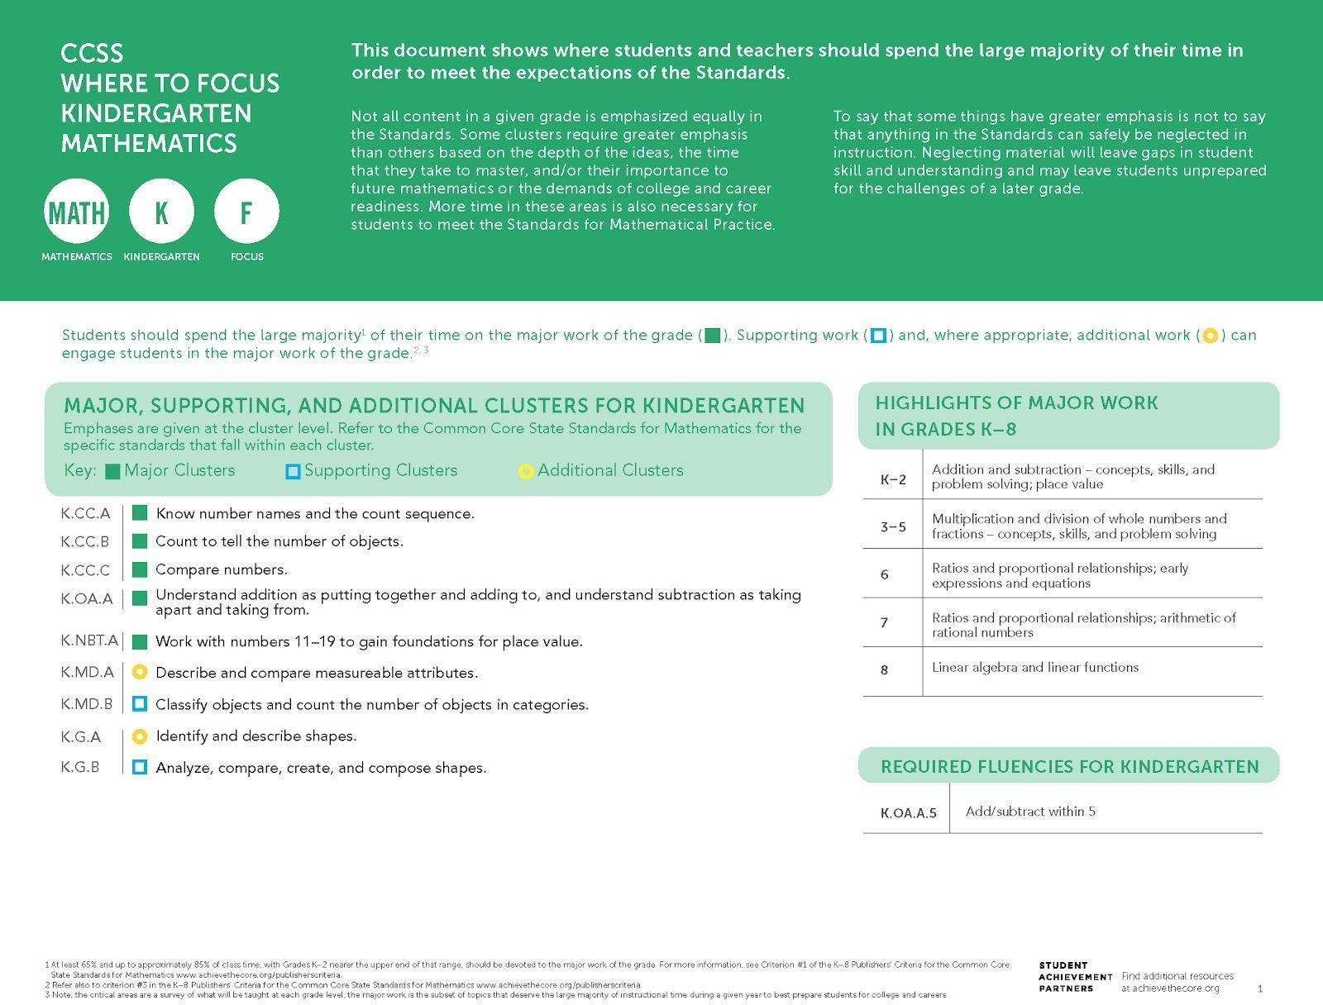

College- and career-ready mathematics standards have important emphases at each grade level, which for kindergarten are highlighted in this Focus Document. The considerations for the 2020–21 school year that follow are intended to be a companion to the Focus Document. Users should have both documents in hand, as well as a copy of grade-level standards, when considering these recommendations.

For the 2020–21 school year, prioritization of grade-level mathematical concepts combined with some incorporation of prior-grade knowledge and skills will be
essential to support all students in meeting grade-level expectations. For these unique times, Student Achievement Partners has developed additional guidance above and beyond what is communicated through the major work designations. As described at greater length on the previous page, the following tables:
- Name essential instructional content at each grade;
- Provide considerations for addressing grade-level content in a coherent way;
- Articulate selected content from the prior grade that may be needed to support students in fully engaging with grade-level mathematics;
- Suggest where adaptations can be made to allow for additional time on the most important topics; and
- Provide suggestions for ways to promote social, emotional, and academic development (SEAD) in grade-level mathematics learning, often through the Standards for Mathematical Practice.
The considerations repeatedly use several verbs, such as combine, integrate, etc. The verbs most commonly used in the considerations are italicized below and defined in a glossary in the Appendix. Note that content is designated at the cluster level when the guidance refers to the cluster and its standards, and at the standard level in cases where guidance varies within a cluster.

Considerations for Addressing ESSENTIAL Grade-Level Content
The clusters and standards listed in this table name the essential instructional content for kindergarten. The right-hand column contains approaches to shifting how time is dedicated to the clusters and standards in the left-hand column.
Clusters/Standards | Considerations
See 2015 Nebraska College- and Career-Ready Mathematics Standards 0.1.1.  CCSSM: K.CC.A, K.CC.B, K.CC.C | No special considerations for curricula well aligned to knowing number names, counting, and comparing numbers, as detailed in these clusters. Time spent on instruction and practice should NOT be reduced.
See 2015 Nebraska College- and Career-Ready Mathematics Standards 0.1.2, 0.2.1, and 0.2.3.  CCSSM: K.OA.A | No special considerations for curricula well aligned to understanding addition and subtraction, as detailed in this cluster. Time spent on instruction and practice should NOT be reduced.

Considerations for Addressing REMAINING Grade-Level Content
The clusters and standards listed in this table represent the remainder of kindergarten grade-level content. The right-hand column contains approaches to shifting how time is dedicated to the clusters and standards in the left-hand column.
Clusters/Standards | Considerations
See 2015 Nebraska College- and Career-Ready Mathematics Standards 0.1.1.g.  CCSSM: K.NBT.A* | Combine lessons on numbers 11–19 to address key concepts in order to reduce the amount of time spent on this cluster. Limit the amount of required student practice.
See 2015 Nebraska College- and Career-Ready Mathematics Standards 0.3.3.  CCSSM: K.MD.A | Combine lessons on describing and comparing measurable attributes to address key concepts across this cluster in order to reduce the amount of time spent on this cluster. Limit the amount of required student practice. (Note that standards in K.MD.A do not require use of measuring devices or measurement units.)
See 2015 Nebraska College- and Career-Ready Mathematics Standards 0.4.2.  CCSSM: K.MD.B | Integrate classifying and counting objects (K.MD.B) with other counting and comparison work in the grade (K.CC.A, B, and C) in order to reduce the amount of time spent on this cluster.
See 2015 Nebraska College- and Career-Ready Mathematics Standards 0.3.1 and 0.3.2.  CCSSM: K.G.A and K.G.B | Combine lessons on identifying, describing, analyzing, comparing, and composing shapes to address key concepts across the clusters in this domain in order to reduce the amount of time spent on this cluster.
*While this cluster is Major Work of the Grade, during the 2020–21 school year, it is recommended that it receive lighter treatment in favor of other essential instructional content.

Facilitate Social, Emotional, and Academic Development (SEAD)⁹ Through Grade-Level Content
The left-hand column contains sample actions for how SEAD can be effectively integrated into grade-level mathematics instruction, in connection with Standards for Mathematical Practice named in the right-hand column. Efforts should be made to facilitate SEAD even in remote learning environments, using synchronous and asynchronous approaches and the capabilities afforded by remote learning technologies.
Sample Actions | Connection to Standards for Mathematical Practice (SMP)
Design structured and unstructured time for students to actively collaborate with their classmates to grow their skills in problem solving, cooperation, communication, innovation, reflection,  self-regulation, and empathy (for example, when students are in math centers or when they share tasks such as counting out supplies). | NE Process #1: Solves Mathematical Problems  MP1: Make sense of problems and persevere in solving them.
Promote a sense of belonging by including math routines, such as number talks, choral counting, counting collections, and other counting routines, so that students see themselves as a part of a community. | NE Process #4: Makes Mathematical Connections  MP7: Look for and make use of structure.
Promote skills in cooperation and communication by providing opportunities in daily lessons for students to work in pairs counting objects and practicing fluency within 5. | NE Process #1: Solves Mathematical Problems  MP6: Attend to precision.
⁹ Sample SEAD actions contribute to students’ sense of belonging and safety, efficacy, value for effort and growth, as well as a sense of engagement in work that is relevant and culturally responsive. The actions can be modified to fit any grade, K–8, by considering the content of that grade level. See other grade-level Mathematics Instructional Priorities documents for additional samples.

Grade 1 Mathematics: Essential Instructional Content for 2020-2021

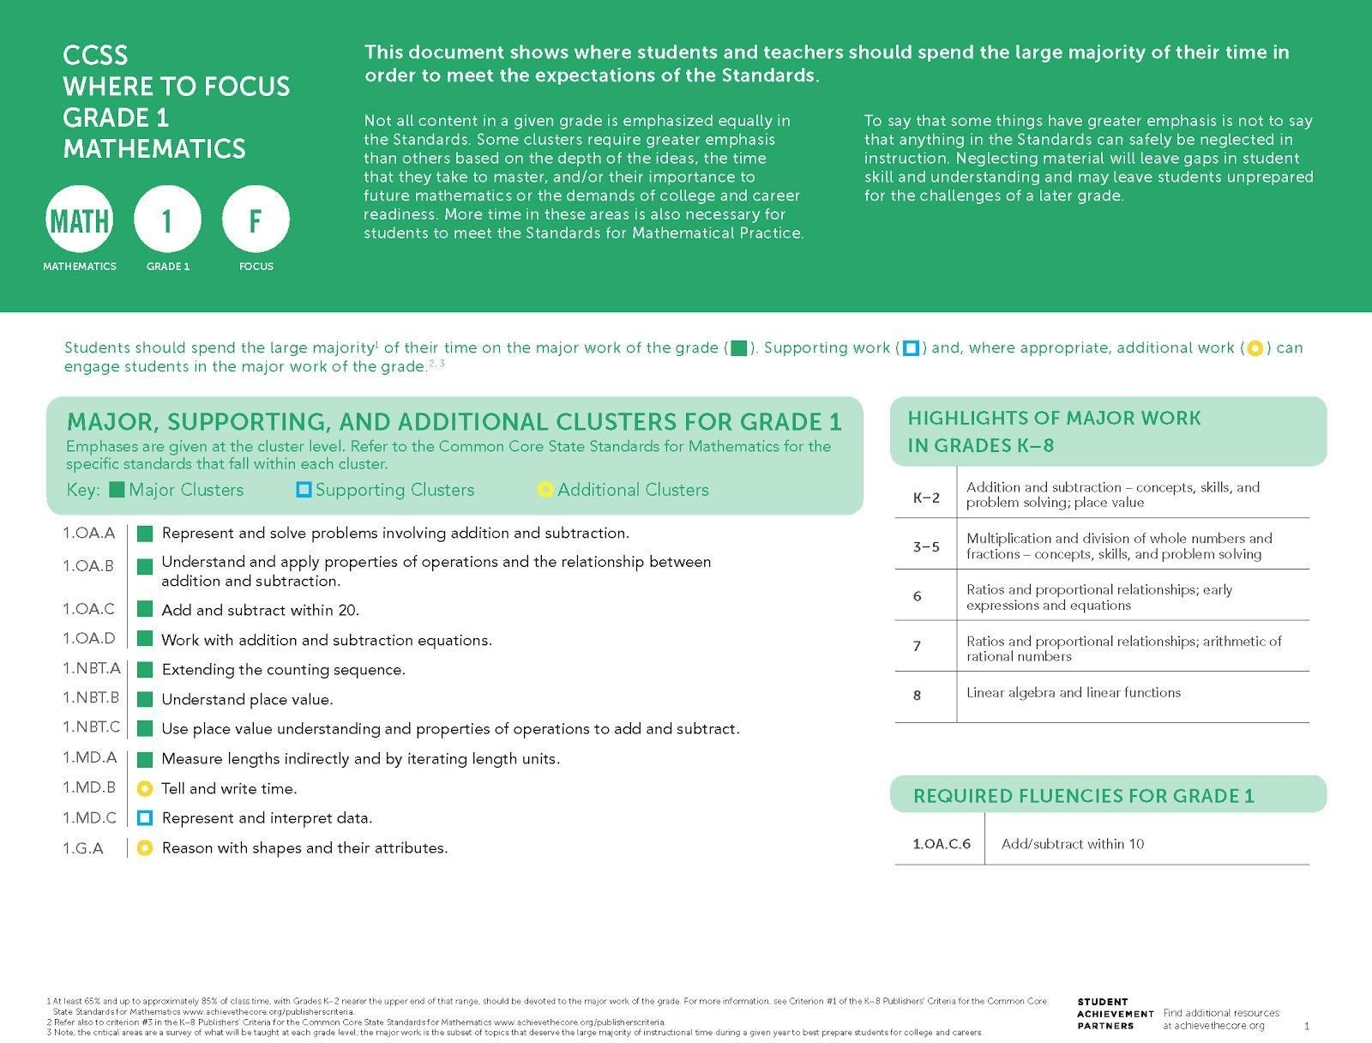

College- and career-ready mathematics standards have important emphases at each grade level, which for grade 1 are highlighted in this Focus Document. The considerations for the 2020–21 school year that follow are intended to be a companion to the Focus Document. Users should have both documents in hand, as well as a copy of grade-level standards, when considering these recommendations.

For the 2020–21 school year, prioritization of grade-level mathematical concepts combined with some incorporation of prior-grade knowledge and skills will be
essential to support all students in meeting grade-level expectations. For these unique times, Student Achievement Partners has developed additional guidance above and beyond what is communicated through the major work designations. As described at greater length on the previous page, the following tables:
- Name essential instructional content at each grade;
- Provide considerations for addressing grade-level content in a coherent way;
- Articulate selected content from the prior grade that may be needed to support students in fully engaging with grade-level mathematics;
- Suggest where adaptations can be made to allow for additional time on the most important topics; and
- Provide suggestions for ways to promote social, emotional, and academic development (SEAD) in grade-level mathematics learning, often through the Standards for Mathematical Practice.

The considerations repeatedly use several verbs, such as combine, integrate, etc. The verbs most commonly used in the considerations are italicized below and defined in a glossary in the Appendix. Note that content is designated at the cluster level when the guidance refers to the cluster and its standards, and at the standard level in cases where guidance varies within a cluster.

Considerations for Addressing ESSENTIAL Grade-Level Content
The clusters and standards listed in this table name the essential instructional content for grade 1. The right-hand column contains approaches to shifting how time is dedicated to the clusters and standards in the left-hand column.
Clusters/Standards | Considerations
See 2015 Nebraska College- and Career-Ready Mathematics Standards 1.2.3.a.  CCSSM: 1.OA.A.1 | Emphasize problems that involve sums less than or equal to 10 and/or the related differences to keep the focus on making sense of different problem types; do not limit the range of addition and subtraction situations, but assign fewer problems with sums greater than 10 or related differences.
See 2015 Nebraska College- and Career-Ready Mathematics Standards 1.2.1.b and 1.2.2.a.  CCSSM: 1.OA.B | No special considerations for curricula well aligned to understanding and applying properties of operations to addition and subtraction, as detailed in this cluster. Time spent on instruction and practice should NOT be reduced.
See 2015 Nebraska College- and Career-Ready Mathematics Standards 1.1.2.a and 1.1.2.b.  CCSSM: 1.OA.C.6 | No special considerations for curricula well aligned to adding and subtracting within 20, as detailed in this standard. Time spent on instruction and practice should NOT be reduced.
See 2015 Nebraska College- and Career-Ready Mathematics Standards 1.2.1.a and 1.2.1.d.  CCSSM: 1.OA.D | No special considerations for curricula well aligned to work with addition and subtraction equations, as detailed in this cluster. Time spent on instruction and practice should NOT be reduced.
See 2015 Nebraska College- and Career-Ready Mathematics Standards 1.1.1.d, 1.1.1.e, and 1.1.1.f.  CCSSM: 1.NBT.B | Incorporate foundational work on understanding that numbers 11–19 are built from ten ones and some further ones (K.NBT.A) to support grade 1 understanding of place value.
See 2015 Nebraska College- and Career-Ready Mathematics Standards 1.1.2.c, 1.1.2.d, and 1.1.2.e.  CCSSM: 1.NBT.C | Emphasize the understanding that in adding two two-digit numbers, one adds tens and tens, ones and ones, and sometimes it is necessary to compose a ten, in order to strengthen the progression toward fluency with  multi-digit addition and subtraction.
See 2015 Nebraska College- and Career-Ready Mathematics Standards 1.3.3.c and 1.3.4.d.  CCSSM: 1.MD.A | No special considerations for curricula well aligned to measuring lengths indirectly by iterating length units, as detailed in this cluster. Time spent on instruction and practice should NOT be reduced.

Considerations for Addressing REMAINING Grade-Level Content
The clusters and standards listed in this table represent the remainder of grade 1 grade-level content. The right-hand column contains approaches to shifting how time is dedicated to the clusters and standards in the left-hand column.
Clusters/Standards | Considerations
See 2015 Nebraska College- and Career-Ready Mathematics Standards 1.2.3.b.  CCSSM: 1.OA.A.2* | Reduce the amount of time spent on lessons and problems that call for addition of three whole numbers. Limit  the amount of required student practice.
See 2015 Nebraska College- and Career-Ready Mathematics Standards 1.2.1.c.  CCSSM: 1.OA.C.5* | Integrate counting into the work of the domain (OA), instead of separate lessons, in order to reduce the amount of time spent on this standard.
See 2015 Nebraska College- and Career-Ready Mathematics Standards 1.1.1.a, 1.1.1.b, and 1.1.1.c.  CCSSM: 1.NBT.A* | Eliminate lessons that are solely about extending the count sequence in order to reduce the amount of time spent on this cluster. Incorporate extending the count sequence into other lessons in the grade.
See 2015 Nebraska College- and Career-Ready Mathematics Standards 1.3.3.b.  CCSSM: 1.MD.B | Eliminate lessons devoted to telling and writing time to the hour and half-hour (1.MD.B.3).
See 2015 Nebraska College- and Career-Ready Mathematics Standards 1.4.1.a and 1.4.2.a.  CCSSM: 1.MD.C | Eliminate lessons devoted to representing and interpreting data. (Do not eliminate problems about using addition and subtraction to solve problems about the data.)
See 2015 Nebraska College- and Career-Ready Mathematics Standards 1.3.1.a, 1.3.1.b, and 1.3.1.c.  CCSSM: 1.G.A | Combine lessons to address key concepts of defining attributes of shapes and composing shapes in order to reduce the amount of time spent on this cluster.
*While these standards or clusters are Major Work of the Grade, during the 2020–21 school year, it is recommended that they receive lighter treatment in favor of other essential instructional content.

Facilitate Social, Emotional, and Academic Development (SEAD)¹⁰ Through Grade-Level Content

The left-hand column contains sample actions for how SEAD can be effectively integrated into grade-level mathematics instruction, in connection with Standards for Mathematical Practice named in the right-hand column. Efforts should be made to facilitate SEAD even in remote learning environments, using synchronous and asynchronous approaches and the capabilities afforded by remote learning technologies.
Sample Actions | Connection to Standards for Mathematical Practice (SMP)
Position students as competent young mathematicians by highlighting their successes with grade-level content (for example, creating their own word problems and becoming fluent with adding and subtracting within 10), as well as by strategically creating just-in-time supports and enrichment that provide every student opportunity to actively engage with grade-level work. | NE Process #1: Solves Mathematical Problems  MP1: Make sense of problems and persevere in solving them.
Communicate collective learning goals for the class as a whole to reinforce that students belong to a learning community where they can succeed and where they will be supported to grow. | NE Process #3: Communicate Mathematical Ideas Effectively  Creating a learning community is essential for mathematical practices such as MP3 that are interpersonal by nature.
Establish norms for participation within routines, such as number talks for addition and subtraction within 20 and choral counting within 120, to position every student as a competent mathematical thinker. | NE Process #4: Makes Mathematical Connections  MP7: Look for and make use of structure.

¹⁰ Sample SEAD actions contribute to students’ sense of belonging and safety, efficacy, value for effort and growth, as well as a sense of engagement in work that is relevant and culturally responsive. The actions can be modified to fit any grade, K–8, by considering the content of that grade level. See other grade-level Mathematics Instructional Priorities documents for additional samples.

Grade 2 Mathematics: Essential Instructional Content for 2020-2021

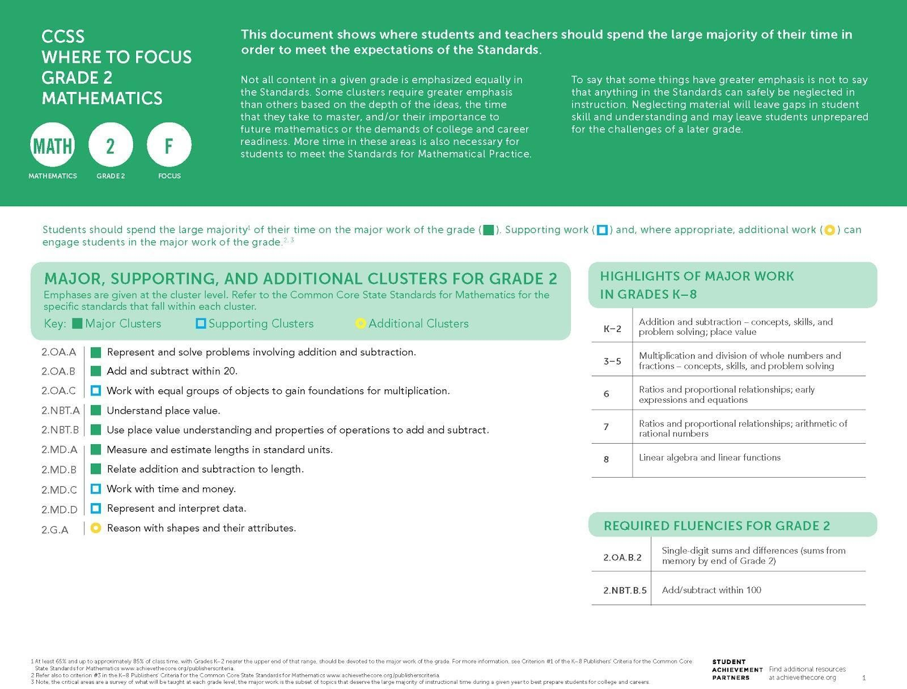

College- and career-ready mathematics standards have important emphases at each grade level, which for grade 2 are highlighted in this Focus Document. The considerations for the 2020–21 school year that follow are intended to be a companion to the Focus Document. Users should have both documents in hand, as well as a copy of grade-level standards, when considering these recommendations.

For the 2020–21 school year, prioritization of grade-level mathematical concepts combined with some incorporation of prior-grade knowledge and skills will be
essential to support all students in meeting grade-level expectations. For these unique times, Student Achievement Partners has developed additional guidance above and beyond what is communicated through the major work designations. As described at greater length on the previous page, the following tables:
- Name essential instructional content at each grade;
- Provide considerations for addressing grade-level content in a coherent way;
- Articulate selected content from the prior grade that may be needed to support students in fully engaging with grade-level mathematics;
- Suggest where adaptations can be made to allow for additional time on the most important topics; and
- Provide suggestions for ways to promote social, emotional, and academic development (SEAD) in grade-level mathematics learning, often through the Standards for Mathematical Practice.

The considerations repeatedly use several verbs, such as combine, integrate, etc. The verbs most commonly used in the considerations are italicized below and defined in a glossary in the Appendix. Note that content is designated at the cluster level when the guidance refers to the cluster and its standards, and at the standard level in cases where guidance varies within a cluster.

Considerations for Addressing ESSENTIAL Grade-Level Content
The clusters and standards listed in this table name the essential instructional content for grade 2. The right-hand column contains approaches to shifting how time is dedicated to the clusters and standards in the left-hand column.
Clusters/Standards | Considerations
See 2015 Nebraska College- and Career-Ready Mathematics Standards 2.2.3.a.  CCSSM: 2.OA.A | Emphasize problems that involve sums less than or equal to 20 and/or the related differences to keep the focus on making sense of different problem types; assign fewer problems with sums greater than 20 or related differences.
See 2015 Nebraska College- and Career-Ready Mathematics Standards 2.1.2.a.  CCSSM: 2.OA.B | Incorporate additional practice on the grade 1 fluency of adding and subtracting within 10 (1.OA.C.6) early in the school year to support the addition and subtraction work of grade 2 (2.OA).
See 2015 Nebraska College- and Career-Ready Mathematics Standards 2.1.2.b, 2.1.2.c, 2.1.2.d, and 2.1.2.e.  CCSSM: 2.NBT.B | Prioritize strategies based on place value in written work to strengthen the progression toward fluency with multi-digit addition and subtraction. (Note that grade 2 students are not expected to be fluent with three-digit sums and differences; repetitive fluency exercises are not required.)  Incorporate foundational work on addition and subtraction within 100 from grade 1 (1.NBT.C) to support the addition and subtraction work of grade 2.
See 2015 Nebraska College- and Career-Ready Mathematics Standards 2.3.3.h.  CCSSM: 2.MD.B.5 | Ensure word problems represent all grade 2 problem types, and refer to guidance for 2.OA.A.
See 2015 Nebraska College- and Career-Ready Mathematics Standards 2.3.3.g.  CCSSM: 2.MD.B.6 | No special considerations for curricula well aligned to representing lengths on number line diagrams, as detailed in this standard. Time spent on instruction and practice should NOT be reduced.

Considerations for Addressing REMAINING Grade-Level Content
The clusters and standards listed in this table represent the remainder of grade 2 grade-level content. The right-hand column contains approaches to shifting how time is dedicated to the clusters and standards in the left-hand column.
Clusters/Standards | Considerations
See 2015 Nebraska College- and Career-Ready Mathematics Standards 2.1.2.f and 2.2.1.a.  CCSSM: 2.OA.C | Eliminate lessons on foundations for multiplication.
See 2015 Nebraska College- and Career-Ready Mathematics Standards 2.1.1.a, 2.1.1.b, 2.1.1.c, 2.1.1.d, and 2.1.1.e.  CCSSM: 2.NBT.A* | Emphasize the conceptual understanding of three-digit numbers (as detailed in 2.NBT.A.1).  Integrate lessons and practice on counting, reading/writing, and comparing numbers (2.NBT.A.2, 3, and 4) into the work of place value. Limit the amount of required student practice on counting by ones, reading/writing, and comparing numbers.
See 2015 Nebraska College- and Career-Ready Mathematics Standards 2.3.3.c, 2.3.3.d, 2.3.3.e, and 2.3.3.f.  CCSSM: 2.MD.A* | Integrate lessons and practice on comparing and estimating lengths (2.MD.A.2, 3, and 4) into the work of measuring length with tools (2.MD.A.1) in order to reduce the amount of time spent on this cluster. Limit the amount of required student practice.
See 2015 Nebraska College- and Career-Ready Mathematics Standards 2.3.3.a and 2.3.3.b.  CCSSM: 2.MD.C | Combine lessons in order to reduce the amount of time spent on time and money. Emphasize denominations that support place value understanding such as penny-dime-dollar. Limit the amount of required student practice.
See 2015 Nebraska College- and Career-Ready Mathematics Standards 2.4.1.a, 2.4.1.b, and 2.4.2.a.  CCSSM: 2.MD.D | Eliminate lessons on generating measurement data (2.MD.D.9) and creating picture/bar graphs (2.MD.D.10).  Integrate data displays only as settings for addition/subtraction word problems (2.OA.A).
See 2015 Nebraska College- and Career-Ready Mathematics Standards 2.3.1.a, 2.3.1.b, 2.3.1.c, and 2.3.1.d.  CCSSM: 2.G.A | Combine lessons to address key concepts on reasoning with shapes and their attributes in order to reduce the amount of time spent on this cluster. Limit the amount of required student practice.
*While these clusters are Major Work of the Grade, during the 2020–21 school year, it is recommended that they receive lighter treatment in favor of other essential instructional content.

Facilitate Social, Emotional, and Academic Development (SEAD)¹¹ Through Grade-Level Content
The left-hand column contains sample actions for how SEAD can be effectively integrated into grade-level mathematics instruction, in connection with Standards for Mathematical Practice named in the right-hand column. Efforts should be made to facilitate SEAD even in remote learning environments, using synchronous and asynchronous approaches and the capabilities afforded by remote learning technologies.
Sample Actions | Connection to Standards for Mathematical Practice (SMP)
Use discussion protocols to provide a safe environment for students to share their developing thinking and to allow for interactions where peers value multiple contributions. | NE Process #3: Communicate Mathematical Ideas Effectively  MP3: Construct viable arguments and critique the reasoning of others.
Design question threads that prompt students to recognize frustration with a problem, manage the frustration without turning their back on the task, re-evaluate, and look for an alternate pathway to a solution. | NE Process #1: Solves Mathematical Problems  MP1: Make sense of problems and persevere in solving them.
Empower students to self-monitor their individual progress as they use properties and patterns along the way toward knowing sums of two one-digit numbers from memory. This monitoring includes reflection and individual recording, supporting their ability to try and try again to show off their improvement. | NE Process #4: Makes Mathematical Connections  MP8: Look for and express regularity in repeated reasoning.
¹¹ Sample SEAD actions contribute to students’ sense of belonging and safety, efficacy, value for effort and growth, as well as a sense of engagement in work that is relevant and culturally responsive. The actions can be modified to fit any grade, K–8, by considering the content of that grade level. See other grade-level Mathematics Instructional Priorities documents for additional samples.

Grade 3 Mathematics: Essential Instructional Content for 2020-2021

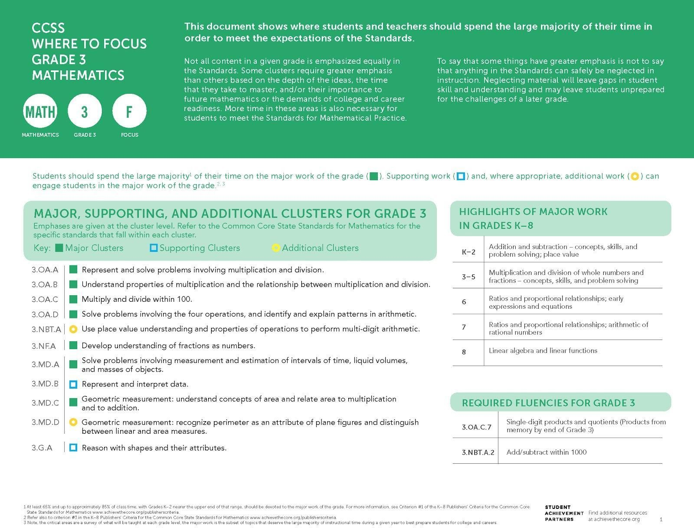

College- and career-ready mathematics standards have important emphases at each grade level, which for grade 3 are highlighted in this Focus Document. The considerations for the 2020–21 school year that follow are intended to be a companion to the Focus Document. Users should have both documents in hand, as well as a copy of grade-level standards, when considering these recommendations.

For the 2020–21 school year, prioritization of grade-level mathematical concepts combined with some incorporation of prior-grade knowledge and skills will be
essential to support all students in meeting grade-level expectations. For these unique times, Student Achievement Partners has developed additional guidance above and beyond what is communicated through the major work designations. As described at greater length on the previous page, the following tables:
- Name essential instructional content at each grade;
- Provide considerations for addressing grade-level content in a coherent way;
- Articulate selected content from the prior grade that may be needed to support students in fully engaging with grade-level mathematics;
- Suggest where adaptations can be made to allow for additional time on the most important topics; and
- Provide suggestions for ways to promote social, emotional, and academic development (SEAD) in grade-level mathematics learning, often through the Standards for Mathematical Practice.

The considerations repeatedly use several verbs, such as combine, integrate, etc. The verbs most commonly used in the considerations are italicized below and defined in a glossary in the Appendix. Note that content is designated at the cluster level when the guidance refers to the cluster and its standards, and at the standard level in cases where guidance varies within a cluster.
Considerations for Addressing ESSENTIAL Grade-Level Content
The clusters and standards listed in this table name the essential instructional content for grade 3. The right-hand column contains approaches to shifting how time is dedicated to the clusters and standards in the left-hand column.
Clusters/Standards | Considerations
See 2015 Nebraska College- and Career-Ready Mathematics Standards 3.2.1.b and 3.2.2.b.  CCSSM: 3.OA.A | No special considerations for curricula well aligned to multiplication and division concepts and problem solving, as detailed in this cluster. Students may need extra support to see row and column structure in arrays of objects. Time spent on instruction and practice should NOT be reduced.
See 2015 Nebraska College- and Career-Ready Mathematics Standards 3.1.2.f, 3.1.2.g, and 3.2.2.a.  CCSSM: 3.OA.B and 3.OA.C | Incorporate additional practice with double-digit sums (2.NBT.B.5) to support the grade 3 multiplication work with the properties of operations, especially the distributive property.
See 2015 Nebraska College- and Career-Ready Mathematics Standards 3.2.3.a and 3.2.3.b.  CCSSM: 3.OA.D.8 | No special considerations for curricula well aligned to two-step word problems using the four operations, as detailed in this standard. Time spent on instruction and practice should NOT be reduced.
See 2015 Nebraska College- and Career-Ready Mathematics Standards 3.1.1.d, 3.1.1.e, 3.1.1.f, 3.1.1.g, and 3.1.1.i.  CCSSM: 3.NF.A | Emphasize the concept of unit fraction as the basis for building fractions. Prioritize the number line as a representation to develop students’ understanding of fractions as numbers by foregrounding the magnitude, location, and order of fractions among whole numbers (3.NF.A.2)

Considerations for Addressing REMAINING Grade-Level Content
The clusters and standards listed in this table represent the remainder of grade 3 grade-level content. The right-hand column contains approaches to shifting how time is dedicated to the clusters and standards in the left-hand column.
Clusters/Standards | Considerations
See 2015 Nebraska College- and Career-Ready Mathematics Standards 3.2.1.a.  CCSSM: 3.OA.D.9* | Eliminate lessons or problems on arithmetic patterns.
See 2015 Nebraska College- and Career-Ready Mathematics Standards 3.1.1.c.  CCSSM: 3.NBT.A.1 | Combine lessons on rounding in order to reduce the amount of time spent on rounding numbers. Limit the amount of required student practice.
See 2015 Nebraska College- and Career-Ready Mathematics Standards 3.1.2.a and 3.1.2.c.  CCSSM: 3.NBT.A.2 | No special considerations for curricula well aligned to addition and subtraction within 1000, as detailed in this standard. Time spent on instruction and practice should not exceed what would be spent in a typical year.
See 2015 Nebraska College- and Career-Ready Mathematics Standards 3.1.2.e.  CCSSM: 3.NBT.A.3 | Combine lessons in order to reduce time spent multiplying by multiples of 10. Emphasize the connection to single-digit products and tens units.
See 2015 Nebraska College- and Career-Ready Mathematics Standards 3.3.3.d.  CCSSM: 3.MD.A* | Combine lessons in order to reduce the amount of time spent on time, volume, and mass. Reduce the amount of required student practice.
See 2015 Nebraska College- and Career-Ready Mathematics Standards 3.4.1.a.  CCSSM: 3.MD.B.3 | Eliminate lessons on creating scaled graphs. Integrate a few problems with scaled graphs only as settings for multiplication word problems (3.OA.A.3) and two-step word problems (3.OA.8).
See 2015 Nebraska College- and Career-Ready Mathematics Standards 3.4.1.a.  CCSSM: 3.MD.B.4 | Eliminate any lessons or problems that do not strongly reinforce the fraction work of this grade (3.NF.A). Incorporate foundational work measuring with rulers (2.MD.A) to support entry into generating fractional measurement data in grade 3.
See 2015 Nebraska College- and Career-Ready Mathematics Standards 3.3.3.f and 3.3.3.g.  3.MD.C* | Emphasize enduring concepts of geometric measurement (iterating a unit with no gaps or overlaps) (3.MD.C.5) and students using area models to support their mathematical explanations involving the distributive property for products (3.MD.C.7c). Combine lessons in order to reduce the amount of time spent on measuring area and limit the amount of required student practice.
See 2015 Nebraska College- and Career-Ready Mathematics Standards 3.3.3.a and 3.3.3.h.  CCSSM: 3.MD.D | Integrate a few problems on perimeter into work on area (3.MD.C).
See 2015 Nebraska College- and Career-Ready Mathematics Standards 3.3.1.b.  CCSSM: 3.G.A.1 | Combine lessons on shapes and their attributes in order to reduce the amount of time spent on this standard.
See 2015 Nebraska College- and Career-Ready Mathematics Standards 3.3.1.c.  CCSSM: 3.G.A.2 | Eliminate separate geometry lessons on partitioning shapes.

*While these clusters are Major Work of the Grade, during the 2020–21 school year, it is recommended that they receive lighter treatment in favor of other essential instructional content.

Facilitate Social, Emotional, and Academic Development (SEAD)¹² Through Grade-Level Content
The left-hand column contains sample actions for how SEAD can be effectively integrated into grade-level mathematics instruction, in connection with Standards for Mathematical Practice named in the right-hand column. Efforts should be made to facilitate SEAD even in remote learning environments, using synchronous and asynchronous approaches and the capabilities afforded by remote learning technologies.
Sample Actions | Connection to Standards for Mathematical Practice (SMP)
Establish discussion protocols to facilitate students' engagement in peer-to-peer mathematical discourse (for example, about the meaning of multiplication and division, reasoning about fractions) that supports active listening, values diverse perspectives and insights, sets team roles, and ensures there is equity of voice and responsibility. | NE Process #1: Solves Mathematical Problems  MP6: Attend to precision.
Attend to the ways in which students position one another as capable or not capable of doing mathematics and provide opportunities to elevate the voices of marginalized students, such as strategically sharing student work, student thinking, and solutions. | NE Process #3: Communicate Mathematical Ideas Effectively  MP3: Construct viable arguments and critique the reasoning of others.
Draw on knowledge and experiences that students bring to mathematics (culture, contexts, language, and experiences) by using multiple representations and contexts (for example, when working with multiplication and division situations). | NE Process #3: Communicate Mathematical Ideas Effectively  MP2: Reason abstractly and quantitatively.

¹² Sample SEAD actions contribute to students’ sense of belonging and safety, efficacy, value for effort and growth, as well as a sense of engagement in work that is relevant and culturally responsive. The actions can be modified to fit any grade, K–8, by considering the content of that grade level. See other grade-level Mathematics Instructional Priorities documents for additional samples.

Grade 4 Mathematics: Essential Instructional Content for 2020-2021

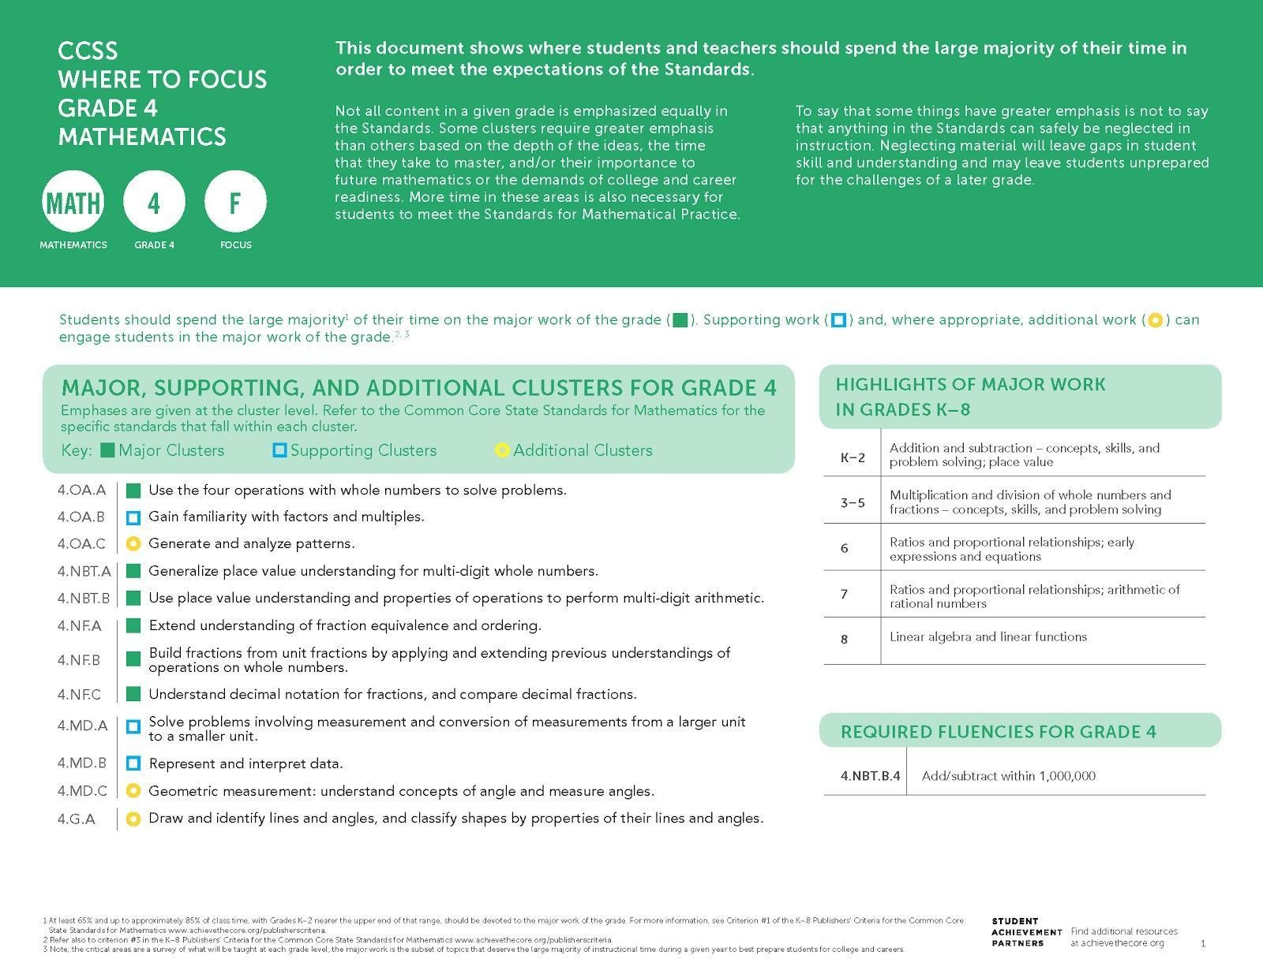

College- and career-ready mathematics standards have important emphases at each grade level, which for grade 4 are highlighted in this Focus Document. The considerations for the 2020–21 school year that follow are intended to be a companion to the Focus Document. Users should have both documents in hand, as well as a copy of grade-level standards, when considering these recommendations.

For the 2020–21 school year, prioritization of grade-level mathematical concepts combined with some incorporation of prior-grade knowledge and skills will be
essential to support all students in meeting grade-level expectations. For these unique times, Student Achievement Partners has developed additional guidance above and beyond what is communicated through the major work designations. As described at greater length on the previous page, the following tables:
- Name essential instructional content at each grade;
- Provide considerations for addressing grade-level content in a coherent way;
- Articulate selected content from the prior grade that may be needed to support students in fully engaging with grade-level mathematics;
- Suggest where adaptations can be made to allow for additional time on the most important topics; and
- Provide suggestions for ways to promote social, emotional, and academic development (SEAD) in grade-level mathematics learning, often through the Standards for Mathematical Practice.

The considerations repeatedly use several verbs, such as combine, integrate, etc. The verbs most commonly used in the considerations are italicized below and defined in a glossary in the Appendix. Note that content is designated at the cluster level when the guidance refers to the cluster and its standards, and at the standard level in cases where guidance varies within a cluster.

Considerations for Addressing ESSENTIAL Grade-Level Content
The clusters and standards listed in this table name the essential instructional content for grade 4. The right-hand column contains approaches to shifting how time is dedicated to the clusters and standards in the left-hand column.
Clusters/Standards | Considerations
See 2015 Nebraska College- and Career-Ready Mathematics Standards 4.1.2.h, 4.2.2.a, and 4.2.3.a.  CCSSM; 4.OA.A | No special considerations for curricula well aligned to analyzing and solving multi-step word problems with the four operations (4.OA.3), and extending multiplicative thinking beyond grade 3 to solve problems involving comparison and the idea of times-as-many/times-as-much (4.OA.2).
See 2015 Nebraska College- and Career-Ready Mathematics Standards 4.1.1.a, 4.1.1.b, 4.1.1.f, and 4.1.1.g.  CCSSM: 4.NBT.A | No special considerations for curricula well aligned to generalizing place value understanding, as detailed in this cluster. Time spent on instruction and practice should NOT be reduced.
See 2015 Nebraska College- and Career-Ready Mathematics Standards 4.1.1.i and 4.1.1.k.  CCSSM: 4.NF.A | No special considerations for curricula well aligned to fraction equivalence and ordering, as detailed in this cluster. Incorporate some foundational work on simple equivalent fractions (3.NF.A.3). Time spent on instruction and practice should NOT be reduced.
See 2015 Nebraska College- and Career-Ready Mathematics Standards 4.1.1.h.  CCSSM: 4.NF.C | No special considerations for curricula well aligned to concepts of decimal fractions, as detailed in this cluster. Time spent on instruction and practice should NOT be reduced.

Considerations for Addressing REMAINING Grade-Level Content
The clusters and standards listed in this table represent the remainder of grade 4 grade-level content. The right-hand column contains approaches to shifting how time is dedicated to the clusters and standards in the left-hand column.
Clusters/Standards | Considerations
See 2015 Nebraska College- and Career-Ready Mathematics Standards 4.1.1.c, 4.1.1.d, and 4.1.1.e.  CCSSM: 4.OA.B | Incorporate opportunities to solidify the fluency expectations of 3.OA.C.7 by giving additional practice sets related to products of single-digit factors and related quotients (with unknowns in all positions) into the grade 4 work of gaining familiarity with factors and multiples.
See 2015 Nebraska College- and Career-Ready Mathematics Standards 4.2.1.b.  CCSSM: 4.OA.C | Eliminate lessons on generating and analyzing patterns.
See 2015 Nebraska College- and Career-Ready Mathematics Standards 4.1.2.a, 4.1.2.b, 4.1.2.c, and 4.1.2.d.  CCSSM: 4.NBT.B* | In relation to fluency expectations for subtracting multi-digit numbers, emphasize problems with only one regrouping step (4.NBT.B.4), in order to reduce algorithmic complexity.  Incorporate fluency expectations of 3.OA.C.7 by giving additional practice sets related to products of single-digit factors and related quotients (with unknowns in all positions) into the grade 4 work on multi-digit multiplication and division (4.NBT.5 & 6). (Note that there are no fluency expectations for multi-digit multiplication or division in grade 4; repetitive fluency exercises are not required.)
See 2015 Nebraska College- and Career-Ready Mathematics Standards 4.1.1.l, 4.1.2.e, 4.1.2.f, 4.1.2.g, and 4.2.3.b.  CCSSM: 4.NF.B* | Emphasize reasoning with unit fractions to determine sums and products, not committing calculation rules to memory or engaging in repetitive fluency exercises.  Incorporate some foundational work on the meaning of the unit fraction (3.NF.A.1 & 2), especially through partitioning the whole on a number line diagram.
See 2015 Nebraska College- and Career-Ready Mathematics Standards 4.3.3.c.  CCSSM: 4.MD.A.1 | No special considerations for curricula well aligned to measurement conversion, as detailed in this standard. Time spent on instruction and practice should not exceed what would be spent in a typical year.
See 2015 Nebraska College- and Career-Ready Mathematics Standards 4.3.3.a and 4.3.3.b.  CCSSM: 4.MD.A.2 and 4.MD.A.3 | Combine lessons on problems involving measurement, except for those on measurement conversion (see 4.MD.A.1). Limit the amount of required student practice.
See 2015 Nebraska College- and Career-Ready Mathematics Standards 4.4.1.a and 4.4.2.a.  CCSSM: 4.MD.B | Eliminate lessons and problems that do not strongly reinforce the fraction work of this grade (4.NF).
See 2015 Nebraska College- and Career-Ready Mathematics Standards 4.3.1.a, 4.3.1.f, and 4.3.1.h.  CCSSM: 4.MD.C.5 and 4.MD.C.6 | Emphasize the foundational understanding of a one-degree angle as a unit of measure (4.MD.C.5a) and use that as the basis for measuring and drawing angles with protractors (4.MD.C.6).
CCSSM: 4.MD.C.7 | Eliminate lessons on recognizing angle measure as additive.
See 2015 Nebraska College- and Career-Ready Mathematics Standards 4.3.1.b, 4.3.1.c, 4.3.1.d, 4.3.1.e, and 4.3.1.h.  CCSSM: 4.G.A | Combine lessons on drawing and identifying lines and angles and classifying shapes by properties. Limit the amount of required student practice.
*While these clusters are Major Work of the Grade, during the 2020–21 school year, it is recommended that they receive lighter treatment in favor of other essential instructional content.

Facilitate Social, Emotional, and Academic Development (SEAD)¹³ Through Grade-Level Content
The left-hand column contains sample actions for how SEAD can be effectively integrated into grade-level mathematics instruction, in connection with Standards for Mathematical Practice named in the right-hand column. Efforts should be made to facilitate SEAD even in remote learning environments, using synchronous and asynchronous approaches and the capabilities afforded by remote learning technologies.
Sample Actions | Connection to Standards for Mathematical Practice (SMP)
Bring in students’ funds of knowledge and past mathematical experiences by providing access to a wide variety of math tools when working on grade-level math (for example, providing number lines when studying equivalent fractions). | NE Process #1: Solves Mathematical Problems  MP5: Use appropriate tools strategically.
Position students as mathematically competent by creating a safe space for students to share their developing reasoning (for example, when they make conjectures and arguments about whole numbers to determine whether they apply to fractions and decimals). | NE Process #3: Communicate Mathematical Ideas Effectively  MP3: Construct viable arguments and critique the reasoning of others.
Establish clear learning goals that promote mathematical learning as just, equitable, and inclusive. For example, in work with subtraction of multi-digit numbers, begin with one regrouping step using evidence of student learning to determine next steps (exit tickets, assigned problem). | NE Process #4: Makes Mathematical Connections  MP7: Look for and make use of structure.

¹³ Sample SEAD actions contribute to students’ sense of belonging and safety, efficacy, value for effort and growth, as well as a sense of engagement in work that is relevant and culturally responsive. The actions can be modified to fit any grade, K–8, by considering the content of that grade level. See other grade-level Mathematics Instructional Priorities documents for additional samples.

Grade 5 Mathematics: Essential Instructional Content for 2020-2021

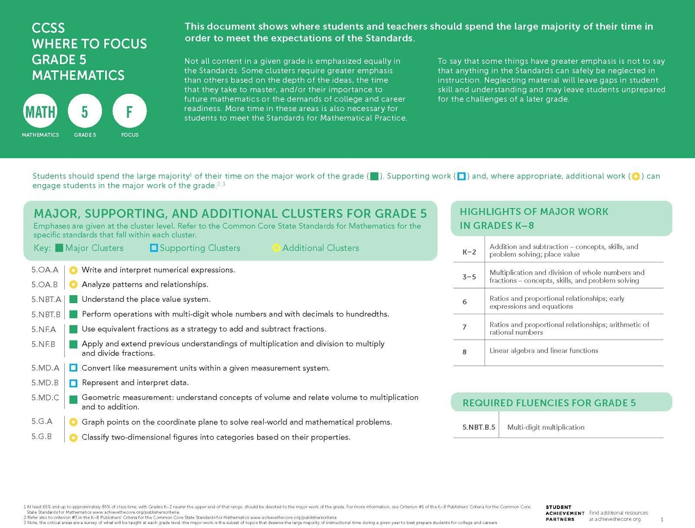

College- and career-ready mathematics standards have important emphases at each grade level, which for grade 5 are highlighted in this Focus Document. The considerations for the 2020–21 school year that follow are intended to be a companion to the Focus Document. Users should have both documents in hand, as well as a copy of grade-level standards, when considering these recommendations.

For the 2020–21 school year, prioritization of grade-level mathematical concepts combined with some incorporation of prior-grade knowledge and skills will be
essential to support all students in meeting grade-level expectations. For these unique times, Student Achievement Partners has developed additional guidance above and beyond what is communicated through the major work designations. As described at greater length on the previous page, the following tables:
- Name essential instructional content at each grade;
- Provide considerations for addressing grade-level content in a coherent way;
- Articulate selected content from the prior grade that may be needed to support students in fully engaging with grade-level mathematics;
- Suggest where adaptations can be made to allow for additional time on the most important topics; and
- Provide suggestions for ways to promote social, emotional, and academic development (SEAD) in grade-level mathematics learning, often through the Standards for Mathematical Practice.

The considerations repeatedly use several verbs, such as combine, integrate, etc. The verbs most commonly used in the considerations are italicized below and defined in a glossary in the Appendix. Note that content is designated at the cluster level when the guidance refers to the cluster and its standards, and at the standard level in cases where guidance varies within a cluster.

Considerations for Addressing ESSENTIAL Grade-Level Content
The clusters and standards listed in this table name the essential instructional content for grade 5. The right-hand column contains approaches to shifting how time is dedicated to the clusters and standards in the left-hand column.
Clusters/Standards | Considerations
See 2015 Nebraska College- and Career-Ready Mathematics Standards 5.1.1.a, 5.1.1.b, 5.1.1.c, and 5.1.1.e.  CCSSM: 5.NBT.A | Allow for time to develop students’ understanding of the foundational work of decimal fractions (4.NF.C) to support entry into understanding the place value system with decimals (5.NBT.A.1, 3, and 4).
See 2015 Nebraska College- and Career-Ready Mathematics Standards 5.1.2.a, 5.1.2.b, and 5.1.2.g.  CCSSM: 5.NBT.B | Incorporate foundational work on multiplying and dividing multi-digit whole numbers (4.NBT.B.5 & 6) to support students’ work operating with multi-digit whole numbers and decimals (5.NBT.B). In relation to fluency expectations for multiplying multi-digit numbers, eliminate problems in which either factor has more than three digits.
See 2015 Nebraska College- and Career-Ready Mathematics Standards 5.1.2.g.  CCSSM: 5.NBT.B.7 | Incorporate students’ understanding of decimal fractions (4.NF.C) to support entry into the grade 5 work of operations with decimals.
See 2015 Nebraska College- and Career-Ready Mathematics Standards 5.1.2.h and 5.2.3.a.  CCSSM: 5.NF.A | Incorporate foundational work on equivalent fractions (4.NF.A.1) and on the conceptual understanding underlying fraction addition (4.NF.B.3) to support students’ work on adding and subtracting fractions with unlike denominators (5.NF.A).
See 2015 Nebraska College- and Career-Ready Mathematics Standards 5.1.2.c, 5.1.2.d, 5.1.2.e, 5.1.2.f, and 5.1.2.g.  CCSSM: 5.NF.B | Incorporate foundations for multiplying fractions by whole numbers (4.NF.B.4) to support students’ work in multiplying fractions and whole numbers by fractions (5.NF.4).
See 2015 Nebraska College- and Career-Ready Mathematics Standards 5.3.3.a and 5.3.3.b.  CCSSM: 5.MD.C | No special considerations for curricula well aligned to the work of volume in grade 5, as detailed in this cluster. Time spent on instruction and practice should NOT be reduced.
See 2015 Nebraska College- and Career-Ready Mathematics Standards 5.3.2.a and 5.3.2.b.  CCSSM: 5.G.A | Incorporate foundational understandings of number lines (such as found in the work of 4.NF) into the work of extending number lines to the coordinate plane, as detailed in this cluster. Emphasize interpreting coordinate values of points in the context of a situation.

Considerations for Addressing REMAINING Grade-Level Content
The clusters and standards listed in this table represent the remainder of grade 5 grade-level content. The right-hand column contains approaches to shifting how time is dedicated to the clusters and standards in the left-hand column.
Clusters/Standards | Considerations
See 2015 Nebraska College- and Career-Ready Mathematics Standards 5.2.2.a.  CCSSM: 5.OA.A | Combine lessons on writing and interpreting numerical expressions in order to reduce the amount of time spent on this topic.
See 2015 Nebraska College- and Career-Ready Mathematics Standards 5.2.1.a.  CCSSM: 5.OA.B | Eliminate lessons and problems on analyzing relationships between numerical patterns.
See 2015 Nebraska College- and Career-Ready Mathematics Standards 5.3.3.a.  CCSSM: 5.MD.A | Combine lessons on converting measurement units in order to reduce the amount of time spent on this topic.
No alignment to 2015 Nebraska College- and Career-Ready Mathematics Standards.  CCSSM: 5.MD.B | Eliminate lessons and problems on representing and interpreting data using line plots that do not strongly reinforce the fraction work of this grade (5.NF).
See 2015 Nebraska College- and Career-Ready Mathematics Standards 5.3.1.c.  CCSSM: 5.G.B | Combine lessons on classifying two-dimensional figures into categories based on properties in order to reduce the amount of time spent on this topic.

Facilitate Social, Emotional, and Academic Development (SEAD)¹⁴ Through Grade-Level Content
The left-hand column contains sample actions for how SEAD can be effectively integrated into grade-level mathematics instruction, in connection with Standards for Mathematical Practice named in the right-hand column. Efforts should be made to facilitate SEAD even in remote learning environments, using synchronous and asynchronous approaches and the capabilities afforded by remote learning technologies.
Sample Actions | Connection to Standards for Mathematical Practice (SMP)
Build community by providing group tasks to develop sense making and problem solving while deepening students’ active engagement. | NE Process #1: Solves Mathematical Problems  MP1: Make sense of problems and persevere in solving them.
Gather student perspectives through written or verbal reflection (for example, anticipation guides, exit slips, error analysis, interviews) so that students consider their learning, performance, and growth as learners. | NE Process #3: Communicate Mathematical Ideas Effectively  MP3: Construct viable arguments and critique the reasoning of others.
Position students as mathematically competent by encouraging various entry points and elevating different ways students see and use structure in problems. For example, students might see a 3 × 4 × 5 rectangular prism as three layers of a 4 × 5 array of cubes, as four layers of a 3 × 5 array of cubes, or as five layers of a 3 × 4 array of cubes. | NE Process #4: Makes Mathematical Connections  MP7: Look for and make use of structure.

¹⁴ Sample SEAD actions contribute to students’ sense of belonging and safety, efficacy, value for effort and growth, as well as a sense of engagement in work that is relevant and culturally responsive. The actions can be modified to fit any grade, K–8, by considering the content of that grade level. See other grade-level Mathematics Instructional Priorities documents for additional samples.

Grade 6 Mathematics: Essential Instructional Content for 2020-2021

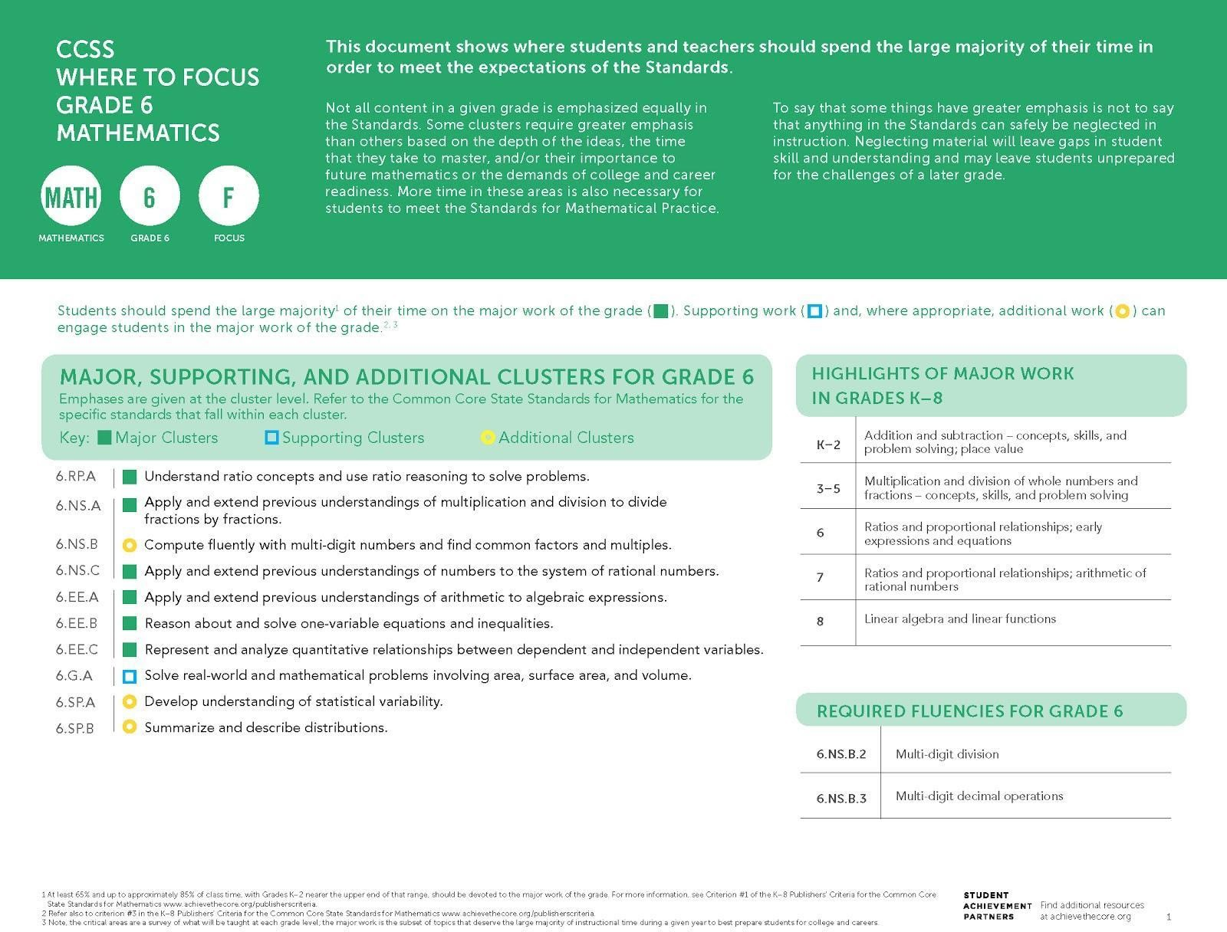

College- and career-ready mathematics standards have important emphases at each grade level, which for grade 6 are highlighted in this Focus Document. The considerations for the 2020–21 school year that follow are intended to be a companion to the Focus Document. Users should have both documents in hand, as well as a copy of grade-level standards, when considering these recommendations.

For the 2020–21 school year, prioritization of grade-level mathematical concepts combined with some incorporation of prior-grade knowledge and skills will be
essential to support all students in meeting grade-level expectations. For these unique times, Student Achievement Partners has developed additional guidance above and beyond what is communicated through the major work designations. As described at greater length on the previous page, the following tables:
- Name essential instructional content at each grade;
- Provide considerations for addressing grade-level content in a coherent way;
- Articulate selected content from the prior grade that may be needed to support students in fully engaging with grade-level mathematics;
- Suggest where adaptations can be made to allow for additional time on the most important topics; and
- Provide suggestions for ways to promote social, emotional, and academic development (SEAD) in grade-level mathematics learning, often through the Standards for Mathematical Practice.

The considerations repeatedly use several verbs, such as combine, integrate, etc. The verbs most commonly used in the considerations are italicized below and defined in a glossary in the Appendix. Note that content is designated at the cluster level when the guidance refers to the cluster and its standards, and at the standard level in cases where guidance varies within a cluster.

Considerations for Addressing ESSENTIAL Grade-Level Content
The clusters and standards listed in this table name the essential instructional content for grade 6. The right-hand column contains approaches to shifting how time is dedicated to the clusters and standards in the left-hand column.
Clusters/Standards | Considerations
See 2015 Nebraska College- and Career-Ready Mathematics Standards 6.1.1.d, 6.1.1.e, 6.1.1.f, 6.2.2.f, 6.2.3.c, and 6.2.3.d.  CCSSM: 6.RP.A | No special considerations for curricula well aligned to understanding ratio concepts and using ratio reasoning to solve problems, as detailed in this cluster. Time spent on instruction and practice should NOT be reduced.
See 2015 Nebraska College- and Career-Ready Mathematics Standards 6.1.2.a.  CCSSM: 6.NS.A | Incorporate foundational work on division with unit fractions and whole numbers (5.NF.B.7) in the early part of students’ work on fraction division (6.NS.A).
See 2015 Nebraska College- and Career-Ready Mathematics Standards 6.1.1.c, 6.1.1.g, 6.1.1.h, 6.1.1.i, and 6.3.2.c.  CCSSM: 6.NS.C | Incorporate foundational work on the coordinate plane (5.G.A.1) to support students’ entry into this cluster.
See 2015 Nebraska College- and Career-Ready Mathematics Standards 6.1.1.b, 6.1.2.b, 6.2.1.a, 6.2.1.b, 6.2.1.c, 6.2.2.c, and 6.2.2.d.  CCSSM: 6.EE.A | Emphasize equivalent expressions (6.EE.A.3 and 4), particularly the idea that applying properties of operations to an expression always results in an expression that is equivalent to the original one.
See 2015 Nebraska College- and Career-Ready Mathematics Standards 6.2.2.b, 6.2.2.e, 6.2.2.g, 6.2.3.a, and 6.2.3.b.  CCSSM: 6.EE.B | No special considerations for curricula well aligned to reasoning about and solving one-variable equations and inequalities, as detailed in this cluster. Time spent on instruction and practice should NOT be reduced.
See 2015 Nebraska College- and Career-Ready Mathematics Standards 6.2.1.c.  CCSSM: 6.EE.C | No special considerations for curricula well aligned to this representing and analyzing quantitative relationships between dependent and independent variables, as detailed in this cluster. Time spent on instruction and practice should NOT be reduced.

Considerations for Addressing REMAINING Grade-Level Content
The clusters and standards listed in this table represent the remainder of grade 6 grade-level content. The right-hand column contains approaches to shifting how time is dedicated to the clusters and standards in the left-hand column.
Clusters/Standards | Considerations
See 2015 Nebraska College- and Career-Ready Mathematics Standards 6.1.2.c, and 6.1.2.d.  CCSSM: 6.NS.B.2 and 6.NS.B.3 | Eliminate lessons on computing fluently (6.NS.B.2 and 3) by integrating these problems into spiraled practice throughout the year. To keep students on track to algebra and avoid inequitable remediation structures, time in grade 6 should not be spent remediating multi-digit calculation algorithms.
See 2015 Nebraska College- and Career-Ready Mathematics Standards 6.1.1.a and 6.2.2.a.  CCSSM: 6.NS.B.4 | No special considerations for curricula well aligned to common factors and multiples, including using distributive property for expressions, as detailed in this standard. Time spent on instruction and practice should not exceed what would be spent in a typical year.
See 2015 Nebraska College- and Career-Ready Mathematics Standards 6.3.2.a, 6.3.2.b, and 6.3.3.a.  CCSSM: 6.G.A.1 | Emphasize understanding of the reasoning leading to the triangle area formula; instead of teaching additional area formulas as separate topics, emphasize problems that focus on finding areas in real-world problems by decomposing figures into triangles and rectangles.
See 2015 Nebraska College- and Career-Ready Mathematics Standards 6.3.3.c.  CCSSM: 6.G.A.2 | Incorporate foundational work on volume (5.MD.C) while working on volumes of right rectangular prisms with fractional edge lengths (6.G.A.2). Emphasize contextual problems, as detailed in the second sentence of the standard; eliminate lessons focused on the first sentence of the standard (finding the volume of a rectangular prism with fractional edge lengths by packing it with unit cubes).
See 2015 Nebraska College- and Career-Ready Mathematics Standards 6.3.2.d and 6.3.2.e.  CCSSM: 6.G.A.3 | Eliminate lessons and problems involving polygons on the coordinate plane.
See 2015 Nebraska College- and Career-Ready Mathematics Standards 6.3.1.a.  CCSSM: 6.G.A.4 | Eliminate lessons and problems on constructing three-dimensional figures from nets and determining if nets can be constructed into three-dimensional figures during the study of nets and surface area.
No alignment to 2015 Nebraska College- and Career-Ready Mathematics Standards.  CCSSM: 6.SP.A | Combine lessons about introductory statistical concepts so as to proceed more quickly to applying and reinforcing these concepts in context. (Note that there are no procedural expectations in the cluster; no procedural practice is required to meet the expectations of the cluster.)
See 2015 Nebraska College- and Career-Ready Mathematics Standards 6.4.1.a and 6.4.2.b.  CCSSM: 6.SP.B | Reduce the amount of required student practice in calculating measures of center and measures of variation by hand, to make room to emphasize the concept of a distribution and the usefulness of summary measures.  Reduce the amount of time spent creating data displays by hand.

Facilitate Social, Emotional, and Academic Development (SEAD)¹⁵ Through Grade-Level Content
The left-hand column contains sample actions for how SEAD can be effectively integrated into grade-level mathematics instruction, in connection with Standards for Mathematical Practice named in the right-hand column. Efforts should be made to facilitate SEAD even in remote learning environments, using synchronous and asynchronous approaches and the capabilities afforded by remote learning technologies.
Sample Actions | Connection to Standards for Mathematical Practice (SMP)
Build a safe community where mathematical discourse supports active listening, promotes diverse perspectives and insights, and allows students to consider others’ reasoning to advance their own mathematical understanding. For example, utilize a “which one doesn't belong?” activity for groups of students to discuss and analyze correspondences between graphs, tables, and equations that represent a relationship between dependent and independent variables. | NE Process #3: Communicate Mathematical Ideas Effectively  MP2: Reason abstractly and quantitatively.
Bring in students’ existing funds of knowledge (culture, contexts, language, and experiences), such as during the study of ratios and rates, when students need to make sense of quantities and relationships in problem situations; they may bring in their understanding of measurement units to do measurement conversions and their real-life interactions with percents to solve percent problems. | NE Process #3: Communicate Mathematical Ideas Effectively  MP2: Reason abstractly and quantitatively.
Position students as mathematically competent by encouraging students to construct mathematical arguments and engage in the reasoning of others, such as when they are using the properties of operations to generate equivalent expressions or working collaboratively to develop the formula for the area of a triangle through analyzing a variety of parallelograms and making an argument to generalize the relationship. | NE Process #3: Communicate Mathematical Ideas Effectively  MP3: Construct viable arguments and critique the reasoning of others.
¹⁵ Sample SEAD actions contribute to students’ sense of belonging and safety, efficacy, value for effort and growth, as well as a sense of engagement in work that is relevant and culturally responsive. The actions can be modified to fit any grade, K–8, by considering the content of that grade level. See other grade-level Mathematics Instructional Priorities documents for additional samples.

Grade 7 Mathematics: Essential Instructional Content for 2020-2021

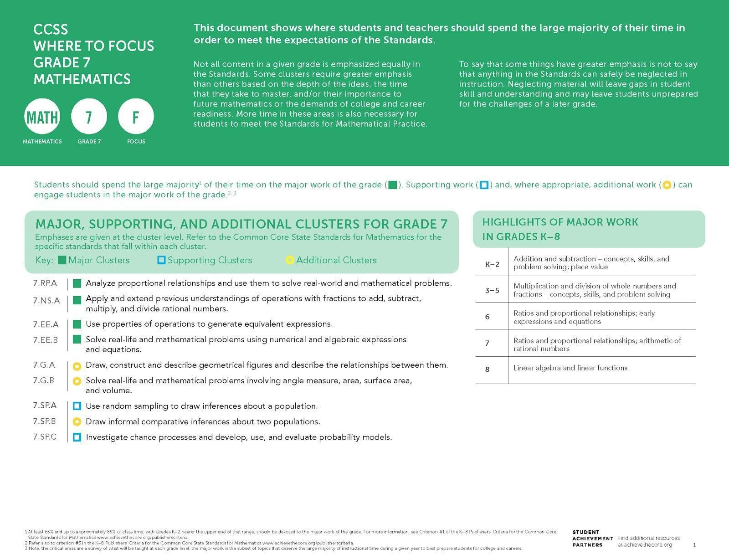

College- and career-ready mathematics standards have important emphases at each grade level, which for grade 7 are highlighted in this Focus Document. The considerations for the 2020–21 school year that follow are intended to be a companion to the Focus Document. Users should have both documents in hand, as well as a copy of grade-level standards, when considering these recommendations.

For the 2020–21 school year, prioritization of grade-level mathematical concepts combined with some incorporation of prior-grade knowledge and skills will be
essential to support all students in meeting grade-level expectations. For these unique times, Student Achievement Partners has developed additional guidance above and beyond what is communicated through the major work designations. As described at greater length on the previous page, the following tables:
- Name essential instructional content at each grade;
- Provide considerations for addressing grade-level content in a coherent way;
- Articulate selected content from the prior grade that may be needed to support students in fully engaging with grade-level mathematics;
- Suggest where adaptations can be made to allow for additional time on the most important topics; and
- Provide suggestions for ways to promote social, emotional, and academic development (SEAD) in grade-level mathematics learning, often through the Standards for Mathematical Practice.

The considerations repeatedly use several verbs, such as combine, integrate, etc. The verbs most commonly used in the considerations are italicized below and defined in a glossary in the Appendix. Note that content is designated at the cluster level when the guidance refers to the cluster and its standards, and at the standard level in cases where guidance varies within a cluster.

Considerations for Addressing ESSENTIAL Grade-Level Content
The clusters and standards listed in this table name the essential instructional content for grade 7. The right-hand column contains approaches to shifting how time is dedicated to the clusters and standards in the left-hand column.
Clusters/Standards | Considerations
See 2015 Nebraska College- and Career-Ready Mathematics Standards 7.1.2.a, 7.2.1.b, 7.2.3.a, and 7.2.3.e.  CCSSM: 7.RP.A | No special considerations for curricula well aligned to analyzing proportional relationships, as detailed by the cluster. Time spent on instruction and practice should NOT be reduced.
See 2015 Nebraska College- and Career-Ready Mathematics Standards 7.1.2.b, 7.1.2.c, and 7.1.2.d.  CCSSM: 7.NS.A | Incorporate foundational work on understandings of rational numbers (6.NS.C.5, 6, and 7) to build towards operations with rational numbers (7.NS.A), as detailed by the cluster.
See 2015 Nebraska College- and Career-Ready Mathematics Standards 7.2.2.a, 7.2.2.b, and 7.2.2.c.  CCSSM: 7.EE.A | Incorporate foundational work on writing and transforming linear expressions from grade 6 (6.EE.A) into the work of using properties of operations to generate equivalent expressions, as detailed by the cluster (7.EE.A).
See 2015 Nebraska College- and Career-Ready Mathematics Standards 7.2.2.d, 7.2.3.a, and 7.2.3.c.  CCSSM: 7.EE.B.3 | No special considerations for curricula well aligned to solving multi-step real-life and mathematical problems, as detailed by the standard. Time spent on instruction and practice should NOT be reduced.
See 2015 Nebraska College- and Career-Ready Mathematics Standards 7.2.1.a and 7.2.3.d.  CCSSM: 7.EE.B.4 | Emphasize equations relative to inequalities. Incorporate foundational work of reasoning about and solving one-variable equations (6.EE.B) to support students’ work on constructing equations to solve problems, as detailed by the standard (7.EE.B.4). Time spent on instruction and practice relating to equations should NOT be reduced.

Considerations for Addressing REMAINING Grade-Level Content
The clusters and standards listed in this table represent the remainder of grade 7 grade-level content. The right-hand column contains approaches to shifting how time is dedicated to the clusters and standards in the left-hand column.
Clusters/Standards | Considerations
See 2015 Nebraska College- and Career-Ready Mathematics Standards 7.2.3.f.  CCSSM: 7.G.A.1 | Reduce time spent creating scale drawings by hand. Time spent on instruction and practice should not exceed what would be spent in a typical year.
See 2015 Nebraska College- and Career-Ready Mathematics Standards 7.3.1.b.  CCSSM: 7.G.A.2 and 7.G.A.3 | Eliminate lessons on drawing and constructing triangles, as detailed in the standard (7.G.A.2). Eliminate lessons on analyzing figures that result from slicing three-dimensional figures, as detailed in the standard (7.G.A.3).
See 2015 Nebraska College- and Career-Ready Mathematics Standards 7.3.3.c.  CCSSM: 7.G.B.4 | Combine lessons on knowing and using the formulas for the area and circumference of a circle in order to reduce the amount of time spent on this topic. Limit the amount of required student practice.
See 2015 Nebraska College- and Career-Ready Mathematics Standards 7.3.1.a, 7.3.3.a, and 7.3.3.b.  CCSSM: 7.G.B.5 and 7.G.B.6 | Combine lessons to address key concepts and skills of unknown angles, area, volume, and surface area (7.G.B.5, 7.G.B.6). Reduce the amount of required student practice.  Incorporate conceptual understanding of finding the area of polygons and the volume of right rectangular prisms (6.G.A.1, 6.G.A.2) in teaching real-life and mathematical problems involving area, volume, and surface area of two- and three-dimensional objects (7.G.B.6). Do not require students to use or draw nets to determine surface area.
See 2015 Nebraska College- and Career-Ready Mathematics Standards 7.4.2.b, 7.4.2.c, and 7.4.2.d.  CCSSM: 7.SP.A and 7.SP.B | Combine lessons on using random sampling to draw inferences about a population and using measures of center and variability to draw comparative inferences about two populations in order to reduce the amount of time spent on this topic. Incorporate students’ grade 6 understanding of statistical variability (6.SP.A). Limit the amount of required student practice.  Eliminate lessons and problems on assessing the degree of overlap on data distributions, as detailed in the standard (7.SP.B.3).

Facilitate Social, Emotional, and Academic Development (SEAD)¹⁶ Through Grade-Level Content
The left-hand column contains sample actions for how SEAD can be effectively integrated into grade-level mathematics instruction, in connection with Standards for Mathematical Practice named in the right-hand column. Efforts should be made to facilitate SEAD even in remote learning environments, using synchronous and asynchronous approaches and the capabilities afforded by remote learning technologies.
Sample Actions | Connection to Standards for Mathematical Practice (SMP)
Bring in students’ funds of knowledge by ensuring materials and problems have a connection with learners while also providing opportunities to learn about the broader world, such as when solving rich tasks involving geometric measurement that have a significant modeling component. | NE Process #2: Models and Represents Mathematical Problems  MP4: Model with mathematics
Communicate that students’ thinking is valued to build trust and rapport by asking questions that elicit students’ thinking, such as when students are analyzing proportional relationships. | NE Process #1: Solves Mathematical Problems  MP1: Make sense of problems and persevere in solving them.
Position students as competent and elevate the status of students by valuing different contributions students make when they share representations and make connections between these representations (for example, tables, graphs, equations, and verbal descriptions of proportional relationships). | NE Process #3: Communicate Mathematical Ideas Effectively  MP3: Construct viable arguments and critique the reasoning of others.
¹⁶ Sample SEAD actions contribute to students’ sense of belonging and safety, efficacy, value for effort and growth, as well as a sense of engagement in work that is relevant and culturally responsive. The actions can be modified to fit any grade, K–8, by considering the content of that grade level. See other grade-level Mathematics Instructional Priorities documents for additional samples.

Grade 8 Mathematics: Essential Instructional Content for 2020-2021

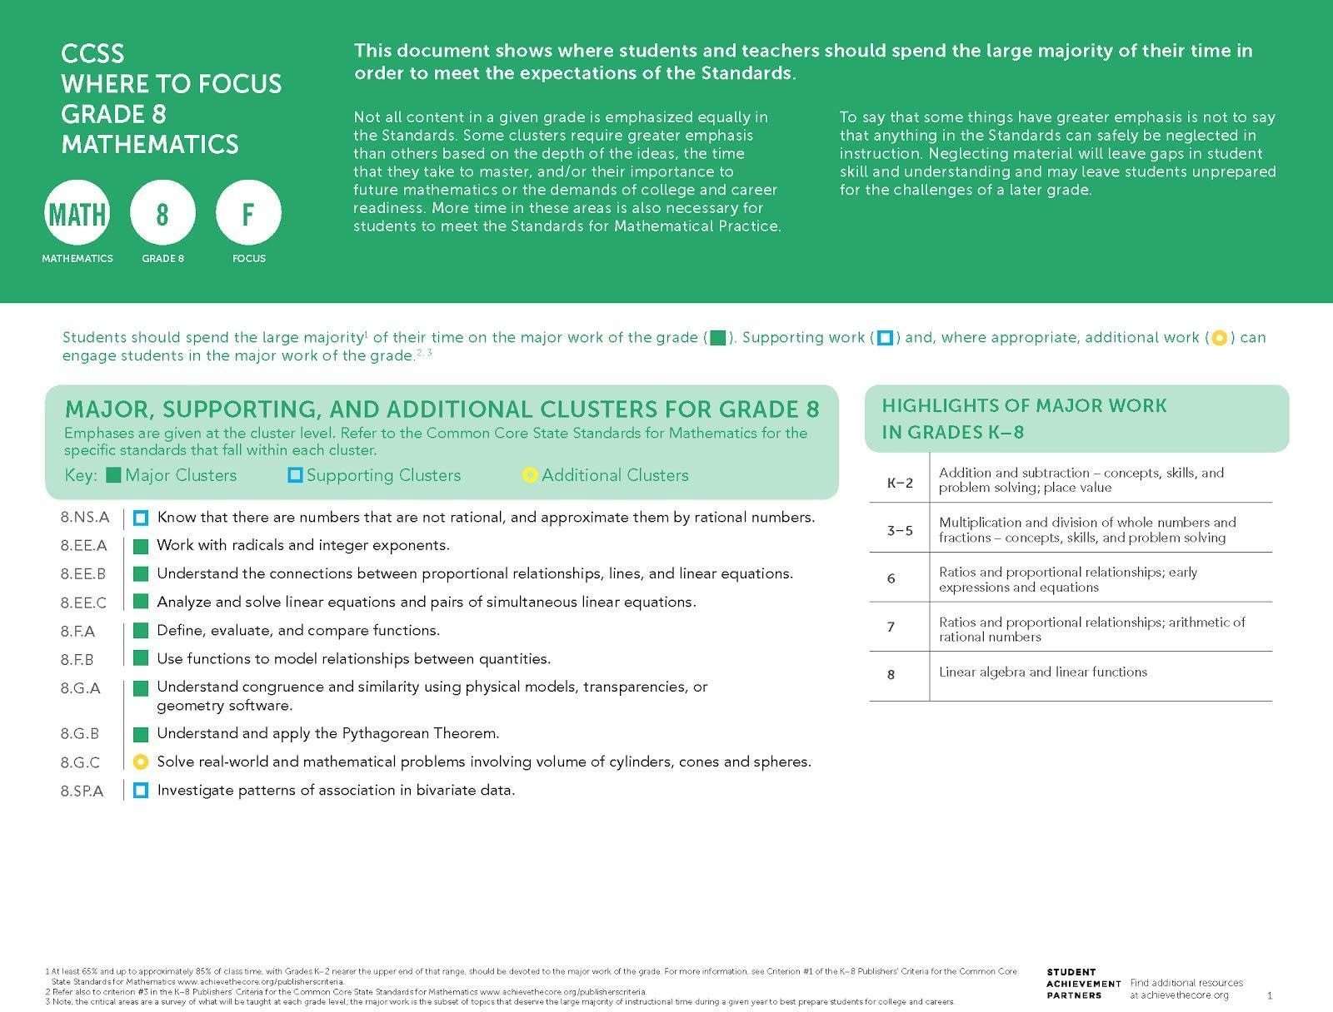

College- and career-ready mathematics standards have important emphases at each grade level, which for grade 8 are highlighted in this Focus Document. The considerations for the 2020–21 school year that follow are intended to be a companion to the Focus Document. Users should have both documents in hand, as well as a copy of grade-level standards, when considering these recommendations.

For the 2020–21 school year, prioritization of grade-level mathematical concepts combined with some incorporation of prior-grade knowledge and skills will be
essential to support all students in meeting grade-level expectations. For these unique times, Student Achievement Partners has developed additional guidance above and beyond what is communicated through the major work designations. As described at greater length on the previous page, the following tables:
- Name essential instructional content at each grade;
- Provide considerations for addressing grade-level content in a coherent way;
- Articulate selected content from the prior grade that may be needed to support students in fully engaging with grade-level mathematics;
- Suggest where adaptations can be made to allow for additional time on the most important topics; and
- Provide suggestions for ways to promote social, emotional, and academic development (SEAD) in grade-level mathematics learning, often through the Standards for Mathematical Practice.

The considerations repeatedly use several verbs, such as combine, integrate, etc. The verbs most commonly used in the considerations are italicized below and defined in a glossary in the Appendix. Note that content is designated at the cluster level when the guidance refers to the cluster and its standards, and at the standard level in cases where guidance varies within a cluster.

Considerations for Addressing ESSENTIAL Grade-Level Content
The clusters and standards listed in this table name the essential instructional content for grade 8. The right-hand column contains approaches to shifting how time is dedicated to the clusters and standards in the left-hand column.
Clusters/Standards | Considerations
See 2015 Nebraska College- and Career-Ready Mathematics Standards 8.1.2.b.  CCSSM: 8.EE.A.1 | No special considerations for curricula well aligned to the work of integer exponents, as detailed by the standard. Time spent on instruction and practice should NOT be reduced.
See 2015 Nebraska College- and Career-Ready Mathematics Standards 8.1.2.a.  CCSSM: 8.EE.A.2 | Eliminate lessons and problems about cube roots.
See 2015 Nebraska College- and Career-Ready Mathematics Standards 8.2.1.d.  CCSSM: 8.EE.B | No special considerations for curricula well aligned to the work of understanding the connections between proportional relationships, lines, and linear equations, as detailed by the cluster. Time spent on instruction and practice should NOT be reduced.
See 2015 Nebraska College- and Career-Ready Mathematics Standards 8.2.1.c, 8.2.2.a, and 8.2.3.c.  CCSSM: 8.EE.C.7 | Incorporate students’ work on rewriting expressions (7.EE.A) and solving algebraic equations (7.EE.B.4) to support students in analyzing and solving one-variable linear equations.
No alignment to 2015 Nebraska College- and Career-Ready Mathematics Standards.  CCSSM: 8.EE.C.8 | Emphasize the correspondences among: (1) a solution to a pair of simultaneous two-variable equations, (2) a point of intersection of the corresponding lines, and (3) the real-world context for which the equations were created. Limit the amount of required student practice in solving systems algebraically.
See 2015 Nebraska College- and Career-Ready Mathematics Standards 8.2.1.a, 8.2.3.a, and 8.2.3.b.  CCSSM: 8.F.A and 8.F.B | No special considerations for curricula well aligned to the domain of Functions, as detailed in the clusters and standards within the domain. Time spent on instruction and practice should NOT be reduced.
See 2015 Nebraska College- and Career-Ready Mathematics Standards 8.3.3.a, 8.3.3.b, and 8.3.3.c.  CCSSM: 8.G.B | No special considerations for curricula well aligned to applying the Pythagorean Theorem to solve real-world and mathematical problems (as detailed by standard 8.G.B.7). Time spent on instruction and practice should NOT be reduced.  Eliminate lessons and problems dedicated to applying the Pythagorean Theorem to find the distance between two points in a coordinate system. Eliminate lessons and problems that require students to develop and/or explain a proof of the Pythagorean Theorem (8.G.B.6). Lessons should present a proof of the theorem to students. Eliminate lessons about the converse of the Pythagorean Theorem.
Considerations for Addressing REMAINING Grade-Level Content
The clusters and standards listed in this table represent the remainder of grade 8 grade-level content. The right-hand column contains approaches to shifting how time is dedicated to the clusters and standards in the left-hand column.
Clusters/Standards | Considerations
See 2015 Nebraska College- and Career-Ready Mathematics Standards 8.1.1.c and 8.1.1.d.  CCSSM: 8.NS.A | Integrate irrational numbers with students' work on square roots (8.EE.A.2) and the Pythagorean Theorem (8.G.B.7).
See 2015 Nebraska College- and Career-Ready Mathematics Standards 8.1.1.b and 8.1.2.d.  CCSSM: 8.EE.A.3* and 8.EE.A.4* | Eliminate lessons and practice dedicated to calculating with scientific notation, but include examples of numbers expressed in scientific notation in lessons about integer exponents, as examples of how integer exponents are applicable outside of mathematics classes (8.EE.A.1).
See 2015 Nebraska College- and Career-Ready Mathematics Standards 8.3.2.a, 8.3.2.b, and 8.3.2.c.  CCSSM: 8.G.A* | Combine lessons to address key concepts in congruence and combine lessons to address key concepts in similarity of two-dimensional figures in order to reduce the amount of time on this topic.
See 2015 Nebraska College- and Career-Ready Mathematics Standards 8.3.3.d.  CCSSM: 8.G.C | Combine lessons to address key concepts with volume, with an emphasis on cylinders, in order to reduce the amount of time on this topic.
See 2015 Nebraska College- and Career-Ready Mathematics Standards 8.4.1.a and 8.4.2.a.  CCSSM: 8.SP.A | Emphasize using linear functions to model association in bivariate measurement data that suggest a linear association, using the functions to answer questions about the data (8.SP.A.3). Combine lessons for 8.SP.A.1, 2, and 4 to address key statistical concepts in order to reduce the amount of time on this topic. Limit the amount of required student practice.
*While these standards or clusters are Major Work of the Grade, during the 2020–21 school year, it is recommended that they receive lighter treatment in favor of other essential instructional content.

Facilitate Social, Emotional, and Academic Development (SEAD)¹⁷ Through Grade-Level Content
The left-hand column contains sample actions for how SEAD can be effectively integrated into grade-level mathematics instruction, in connection with Standards for Mathematical Practice named in the right-hand column. Efforts should be made to facilitate SEAD even in remote learning environments, using synchronous and asynchronous approaches and the capabilities afforded by remote learning technologies.
Sample Actions | Connection to Standards for Mathematical Practice (SMP)
Promote student engagement and identity by embedding systems and routines such as “stronger and clearer each time” or other routines that allow students to engage in productive struggle and take ownership in their progress and growth toward intended learning outcomes. | NE Process #3: Communicate Mathematical Ideas Effectively  MP3: Construct viable arguments and critique the reasoning of others.
Enhance students’ mathematical agency by including regular collaborative opportunities for students to work together with others as a team on modeling tasks that provide multiple pathways for success and that require reasoning and problem solving. | NE Process #3: Communicate Mathematical Ideas Effectively  MP4: Model with mathematics.
Provide opportunities for students to consider tools they may use to solve a problem and justify their appropriateness. For example, they may choose to graph a function defined by expressions to picture the way one quantity depends on the other or use graphing technology to approximate solutions to system of equations | NE Process #1: Solves Mathematical Problems  MP5: Use appropriate tools strategically.

¹⁷ Sample SEAD actions contribute to students’ sense of belonging and safety, efficacy, value for effort and growth, as well as a sense of engagement in work that is relevant and culturally responsive. The actions can be modified to fit any grade, K–8, by considering the content of that grade level. See other grade-level Mathematics Instructional Priorities documents for additional samples.

Appendix

Glossary of the Most Commonly Used Verbs in the Grade-Level Mathematics Recommendations for the 2020–21 School Year
Combine. Give less time and attention to individual lessons by merging a group of lessons in the same domain.

Limit. Cut back on the number of brief, repetitious practice problems that would normally be assigned to students for these topic(s).

Eliminate. Save time by removing the content for this year; the threat to coherence is minimal.

Incorporate. Draw in prior grade-level skills and understandings to support students in engaging successfully with grade-level content. Base decisions related to this additional support on analyses of prior-grade-level scope and sequence and/or factors related to the district-, school-, or classroom-level context.

Integrate. Merge content from the same grade level with other content that has been explicitly specified.

Emphasize/Prioritize. Elevate the importance of one or more standards, concepts, strategies, or problem types above others. Emphasizing is a matter of giving stronger weight to specified things in the cluster or standard, not a matter of limiting entirely to the specified things.

Reduce. Lessen the normal emphasis on specific standards, concepts, strategies, or problem types.

Additional Resources
Charles A. Dana Center at the University of Texas at Austin. (2019). Launch years: Reimagining mathematics education.

Daro, P., & Asturias, H. (2019). Branching out: Designing high school mathematics pathways for equity.

Common Core Standards Writing Team. (2013). Progressions Documents for the Common Core Math Standards. Tucson, AZ: Institute for Mathematics and Education, University of Arizona.

Council of the Great City Schools. (2020). Addressing unfinished learning after COVID-19 school closures. Washington, DC: Author.
w ww.cgcs.org

Formative Assessment for Students and Teachers (FAST) State Collaborative on Assessment and Student Standards (SCASS). (2018). Revising
the Definition of Formative Assessment. Washington, DC: Council of Chief State School Officers.

Kobett, B., & Karp, K.S. (2020). Strengths-based teaching and learning in mathematics: 5 teaching turnarounds for grades K–6. Thousand Oaks, CA: Corwin; Reston, VA: National Council of Teachers of Mathematics.

National Council of Teachers of Mathematics. (2018). Catalyzing change in high school mathematics: Initiating critical conversations.
Reston, VA: Author.

National Council of Teachers of Mathematics. (2020a). Catalyzing change in early childhood and elementary school mathematics: Initiating critical conversations. Reston, VA: Author.

National Council of Teachers of Mathematics. (2020b). Catalyzing change in middle school mathematics: Initiating critical conversations.
Reston, VA: Author.

National Governors Association Center for Best Practices, Council of Chief State School Officers. (2010). Common Core State Standards for
Mathematics. Washington, DC: Author.

Student Achievement Partners. (n.d.). Mathematics: Focus by grade level.

Selected Research
Clements, D., Fuson, K., & Sarama, J. (2017). The research-based balance in early childhood mathematics: A response to Common Core criticisms. Early Childhood Research Quarterly, 40, 150–162.

Geary, D. C., Hoard, M. K., Nugent, L., & Bailey, D. H. (2013). Adolescents’ functional numeracy is predicted by their school entry number system knowledge. PLoS ONE 8(1). www.plosone.org/article/info%3Adoi%2F10.1371%2Fjournal.pone.0054651

Ginsburg, A., Leinwand, S., Anstrom, T., & Pollack, E. (2005). What the United States can learn from Singapore’s world-class mathematics system (and what Singapore can learn from the United States): An exploratory study. American Institutes for Research.
w ww.air.org/files/Singapore_Report_Bookmark_Version1.pdf

Ginsburg, A., Leinwand, S., & Decker, K. (2009). Informing grades 1–6 mathematics standards development: What can be learned from high-performing Hong Kong, Korea, and Singapore? Washington, DC: American Institutes for Research. www.air.org/files/MathStandards.pdf

Jordan, N. C., Kaplan, D., Ramineni, C., & Locuniak, M. N. (2009). Early math matters: Kindergarten number competence and later mathematical outcomes. Developmental Psychology, 45(3), 850–867.

National Center on Education and the Economy (NCEE). (2013). What does it really mean to be college and work ready? The mathematics required of first-year community college students. Washington, DC: Author.
www.ncee.org/wp-content/uploads/2013/05/NCEE_MathReport_May20131.pdf

National Council of Teachers of Mathematics. (2006). Curriculum focal points for prekindergarten through grade 8 mathematics: A quest for coherence. Reston, VA: Author. www.nctm.org/standards/content.aspx?id=270

National Mathematics Advisory Panel. (2008). Foundations for success: Final report of the National Mathematics Advisory Panel. Washington, DC: US Department of Education. www2.ed.gov/about/bdscomm/list/mathpanel/report/final-report.pdf

National Research Council. (2009). Mathematics learning in early childhood: Paths toward excellence and equity. Washington, DC: The National Academies Press. www.nap.edu/catalog.php?record_id=12519

Schmidt, W., & Houang, R. T. (2007). Lack of focus in the intended mathematics curriculum: Symptom or cause? In T. Loveless (Ed.), Lessons learned: What international assessments tell us about math achievement. Washington, DC: Brookings Institution Press.

Schmidt, W., & Houang, R. T. (2012). Curricular coherence and the Common Core State Standards for Mathematics. Educational Researcher, 41(8), 294–308.

Zimba, J. (2014). The development and design of the Common Core State Standards for Mathematics. New England Journal of Public Policy, (26)1, article 10. https://scholarworks.umb.edu/nejpp/vol26/iss1/10/

Zimba, J. (2015). Observations on CCSSM Standards for Mathematical Content: What content is visibly emphasized?

Social, Emotional, and Academic Development (SEAD) Sources
Allensworth, E. M., Farrington, C. A., Gordon, M. F., Johnson, D. W., Klein, K., McDaniel, B., & Nagaoka, J. (2018). Supporting social, emotional, & academic development: Research implications for educators. Chicago, IL: University of Chicago Consortium on School Research.

Aspen Institute. (2019). Integrating social, emotional, and academic development (SEAD): An action guide for school leadership teams. The Aspen Institute Education & Society Program.

Collaborative for Academic, Social, and Emotional Learning. (2013). CASEL guide: Effective social and emotional learning programs—preschool and elementary school edition.

The University of Chicago Urban Education Institute. (2018). Cultivating social, emotional, and academic development. In New knowledge and developments in public education (pp. 11–16).

Wiener, R. (2020). Recovery and renewal: Principles for advancing public education post-crisis. The Aspen Institute Education & Society Program

