Media Outreach Tips & Press Release Template

Media Outreach Tips

Build a media list specific to your area, including local TV stations, newspapers and radio stations. Go online and visit your local media websites to gather contact information. You may want to target reporters who specifically cover education, but generally you’ll want to contact the editor or news director.

Check with each outlet to see how they prefer to receive information. Most prefer email.

If emailing, copy and paste the content from the press release directly into the body of the email. Many journalists delete emails with attachments because they take too much time to download and may contain viruses. Send your press release to one publication at a time to make it more personal. DO NOT CC your entire media list in one email.

After you’ve emailed the press release, contact the editors or reporters by phone to see if they have received the information and if they are interested in doing a follow-up interview.

If you are interviewed, assume that everything you say is “on the record” even if you say something is “off the record.” Don’t assume anything you say before or after the interview won’t be included in the story. Be sure you have parents’ permission for the news outlet to take photographs or video of any of their children.

Press Release Template

The press release will need to be updated with the following, customized to your location:

- Your organization’s logo
- Date
- Your contact information, including phone and email
- How has your facility seen the benefits of Step Up to Quality in your programs?

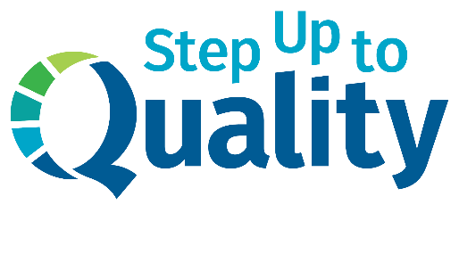
[Add your organization’s logo here]

FOR IMMEDIATE RELEASE
[Insert date]

[Insert contact name & title]
[Insert email address]
[Insert phone number]

Step Up to Quality Celebrates Five Years
[Insert Name of Child Care Facility] sees the benefits of quality childcare practices in its program

[Insert city, state – Insert date] – Quality child care and early childhood education is important in our state’s future. Step Up to Quality is celebrating its five year anniversary in 2019, assisting programs like [Insert name of child care facility] to go beyond state licensing requirements to better serve the needs of young children and their families and to prepare them for success in kindergarten and beyond.

“Five years of Step Up to Quality means we have a significant group of five-year-olds entering kindergarten throughout the entire state that are ready to learn,” said Lauri Cimino, director of Step Up to Quality. “They’re creative, confident and curious learners. Quality early childhood education builds a solid, well-rounded foundation of skills to build from for their entire lives.”

That includes five-year-olds right here in [insert city]. [Insert name of child care facility] has seen the benefits of Step up to Quality in its program. [Insert a quote or example of how Step up to Quality has helped your facility improve.]

With 90 percent of brain development occurring before age 5, early child care and education is crucial to a child’s future success. Early learning builds the foundation for skills needed in school, work and life. Research shows that kids in quality early childhood education programs are more likely to:
- Reach developmental milestones early or on time
- Build emotional intelligence
- Show improved reading skills
- Have better math skills in elementary school
- Be prepared for kindergarten and to become lifelong learners

Step Up to Quality supports early child care and education programs, including licensed family child care homes and child care centers, Head Start and Early Head Start programs, public school-operated early childhood programs and preschools. To learn more about Step Up to Quality, visit stepuptoquality.ne.gov.

###

Step Up to Quality is the state of Nebraska’s Quality Rating and Improvement System (QRIS). A QRIS helps states assess, improve and communicate the level of quality of early childhood programs. Programs are awarded quality ratings for meeting a defined set of program standards. Step Up to Quality is voluntary for most early childhood programs. Programs that receive more than $250,000 in child care subsidies are required to participate. Step Up to Quality is funded through the Nebraska Department of Education and Department of Health and Human Services.

