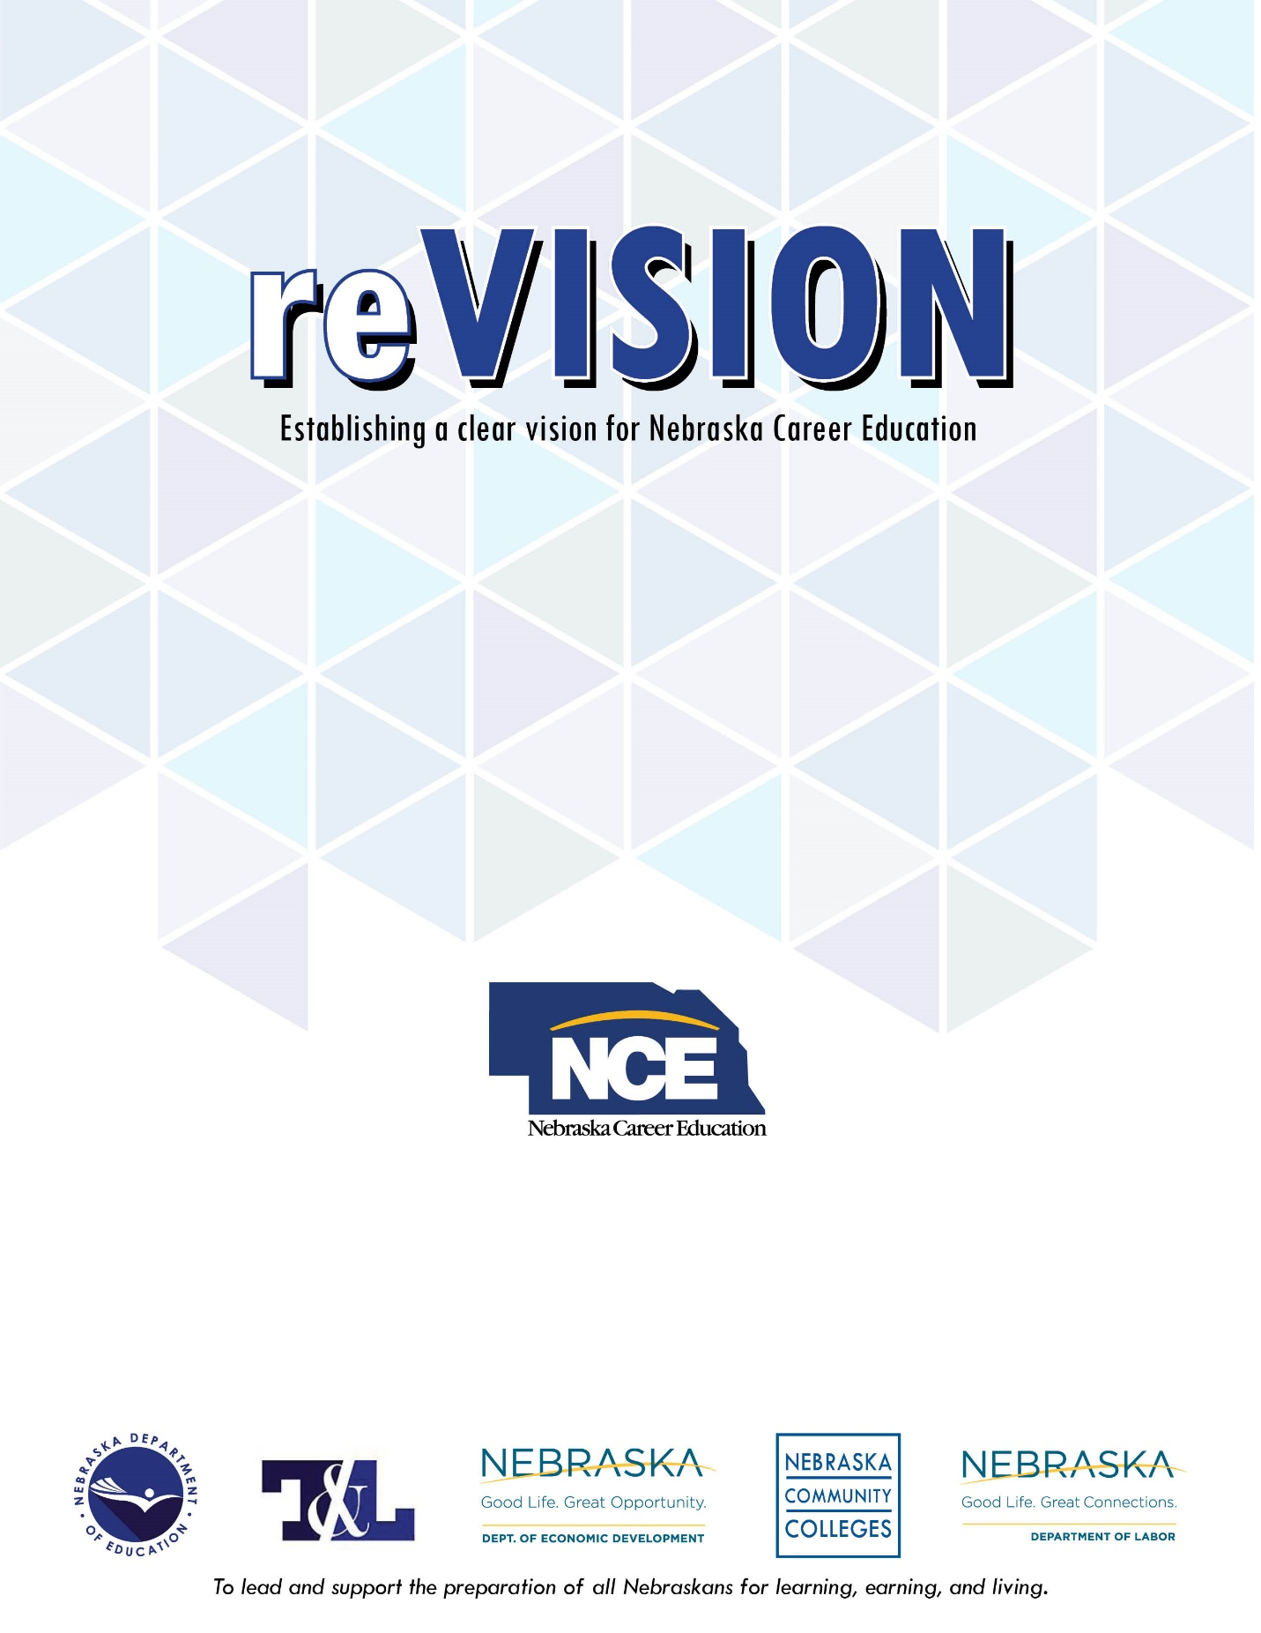
Initial Grant
Application
2019-2020

General Information

Program Overview
The purpose of the Perkins reVISION Initial grant is to assist local school districts in completing the reVISION Career Education strategic planning process.

Working in collaboration with postsecondary education and regional workforce/economic development leaders, the reVISION process links career educators, school administrators, school counselors, industry professionals, and community leaders. Through this process, schools will have the opportunity to analyze and transform their current Career & Technical Education (CTE) system to improve their ability to educate a qualified workforce that meets employers’ needs. This will help ensure that high quality CTE programs are in place in all Nebraska schools, and that such programs are aligned with college and career readiness standards as well as the needs of employers, industry, and labor.

Specifically, the outcomes of reVISION include:
- Aligning and supporting CTE systems with local, regional, and/or statewide economic initiatives
- Developing Nebraska’s talent pipelines for economic growth and workforce development
- Analyzing and updating current CTE Programs of Study and curricular offerings
- Strengthening secondary CE program alignment with Nebraska postsecondary education entrance expectations
- Engaging local/regional businesses in CTE programming

Eligible Recipients
Districts that have not completed a reVISION evaluation process are eligible to participate in this reVISION grant opportunity. An Educational Service Unit (ESU) may apply on behalf of a group of schools and serve as the single fiscal agent for the grant. Similarly, a lead school may apply for a group of schools and serve as the single fiscal agent.

Requirements
Participation in the reVISION process requires the following:
- The identification of a reVISION team. This team should consist of all CTE teachers from each CTE discipline/career field, school counselors, and at least one school administrator (building principal required). In addition, teams may consider additional team members such as school board members, core academic teachers, middle school teachers, or other key stakeholders.
- Participation in a First Meeting facilitated by Nebraska Career Education (NCE) staff. Regional meetings will be held in multiple reVISION districts if appropriate. The First Meeting should be scheduled in October or November if possible.
- Facilitation of a Community Engagement Meeting to be completed by January 15, 2019.
- Participation in a Second Meeting facilitated by NCE staff scheduled after the Community Engagement Meeting. This meeting should be held in January, February, or March to allow adequate time to summarize feedback and key findings.
- Development of a 3-5 year Action Plan that identifies high priority changes for your CTE system.
- Closing out the grant (due April 16, 2020), including the submission of a Final Report, reVISION Action Plan, and final financial claim including itemized printouts detailing the allowable expenditures from the project.

Use of Funds
This grant is intended to assist with implementing the reVISION process in the local district. Perkins funds may only be used to:
- Reimburse substitute teachers to allow teachers to participate in the reVISION process
- Teacher time outside of contract time to prepare for reVISION activities
- Expenses associated with the NCE facilitated and Community Engagement meetings (such as a working meal, materials, etc.)

Please refer to the sample budget on pg. 4 of this grant application.

The maximum amount schools may apply for is $2,000.

Future Funding Opportunities
After successfully completing the reVISION process, districts are eligible to apply for reVISION Action grants for the three consecutive years following completion. reVISION Action grants may be used to help implement the Action Plan developed by the district during the reVISION process.

Additional Questions
If you need assistance or have additional questions, please email: nde.reVISION@nebraska.gov.

(Over)

Basic Application Information

Timeline and Deadlines:
Applications Available: February 4, 2019
Applications Due: May 1, 2019 by 5:00 p.m. CST
Award Notification: June 14, 2019
Grant Award Year: July 1, 2019 - June 30, 2020
Final Closeout Due: April 16, 2020

*Dates are subject to change. Please visit https://www.education.ne.gov/nce/revision for updated information.

Submission Information:
Completed applications should be submitted and uploaded to http://bit.ly/reVISION by May 1, 2019 by 5 p.m. CST.

Application Format
- All applications must be typed and prepared as an Adobe Acrobat .pdf file.
- All applications must be single-spaced in font point size of 10 or higher with top, bottom, and side margins of one inch.
- Applications should not exceed 5 pages in length, excluding the budget and any appendices.
- Each page of the application must include a footer with page number and the name of the local education agency.
- All pages of the application, including the budget, supplemental documents, and cover page should be saved and uploaded as one single .pdf document.

Application Evaluation
As districts submit their grant application, they will be reviewed for eligibility, completeness, and adherence to application requirements. Those that meet the established requirements will be moved forward in the competition.

A review committee will then be established, and may include NCE career field specialist and external individuals with expertise in career education, school reform efforts, and the needs of Nebraska’s economic priorities and workforce demands. The committee will evaluate each eligible application and make recommendations to NCE leadership.

Application Elements

The following outline is provided to support school districts as they develop their applications. The questions below are intended to guide the applicant’s thinking. Feel free to include additional information or materials as deemed relevant for your proposed goals or needs. Page lengths provided after each narrative section are offered as suggestions, not requirements.

Section 1: Goals and Needs (1-2 pages)
Describe the rationale for conducting reVISION in your district. What are the local priorities that align with those of reVISION and the Nebraska Department of Education?

Section 2: Commitment and Capacity (1 page)
Briefly describe your district’s commitment and capacity to carry out all reVISION related activities as described on pages one and two of this application. Also comment on your district’s commitment and capacity to continue the work after the initial reVISION process has concluded and irrespective of future reVISION grant award funds.

Section 3: Budget
As outlined above, this grant is intended to assist with implementing the reVISION process in the local district. Funds may only be used to reimburse substitute teachers to allow teachers to participate in the reVISION process, teacher time outside of contract time to prepare for reVISION activities, and expenses associated with the facilitated face-to-face and Community Engagement meetings (such as a working meal, materials, etc.).

Complete the following proposed budget summary. The maximum award amount is $2,000.

reVISION Initial Grant Budget
Category | Total
Salaries (i.e. subs)
Employee Benefits (i.e. subs)
Purchased Services/Lease Agreements (i.e. working meal)
Supplies & Materials/Operational Equipment(directly related to the reVISION meetings)
Travel & Professional Development (directly related to the reVISION meetings)
TOTAL

Section 4: Meeting Planning

The reVISION process consists of two face-to-face meetings facilitated by NDE staff. All CTE teachers, school counselors, and representatives from the academic core faculty/administrators should plan to attend both meetings. Additionally, there will be a Community Engagement Meeting with local stakeholders. Schools that have used these meetings as faculty professional development days have experienced a great return on the investment of time.

To help plan, the first face-to-face meeting should be scheduled in the fall (October or November) with the second meeting in the early spring (January - March). The Community Engagement Meeting should be conducted between the two NDE facilitated meetings (no later than January 15th).

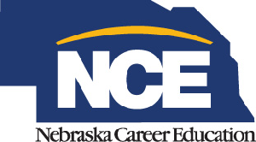

It is the policy of the Nebraska Department of Education not to discriminate on the basis of gender, disability, race, color, religion, marital status, age, or national origin in its education programs, administration, policies, employment, or other agency programs.

