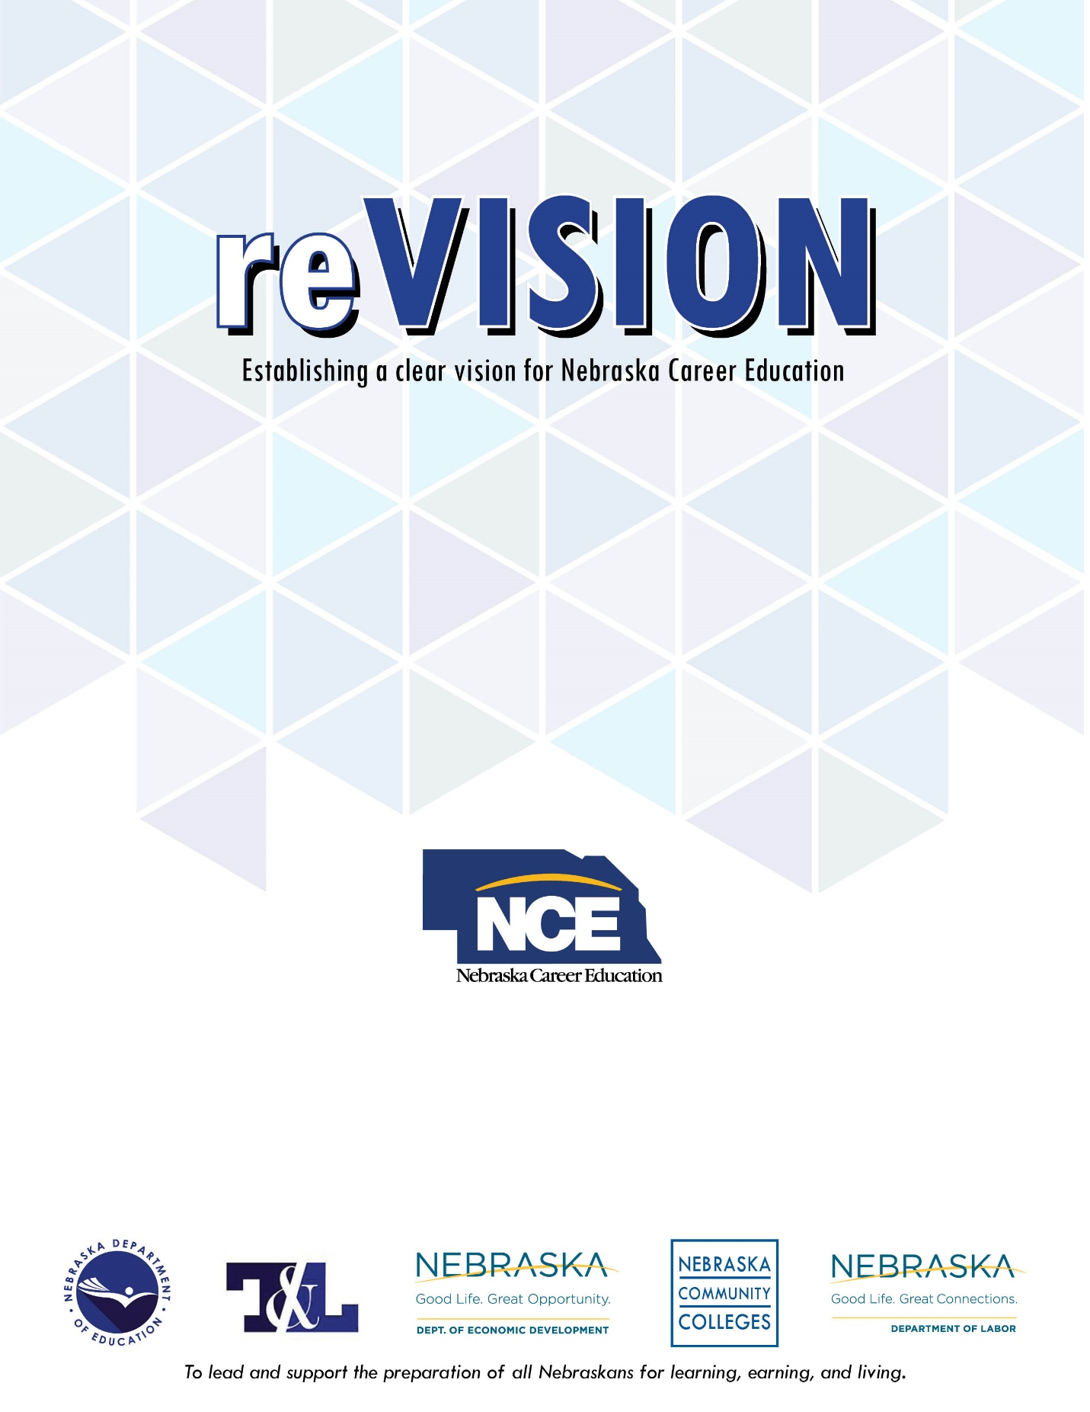
Action Grant
Application
2019-2020

General Information

Program Overview
The purpose of the reVISION Action grant is to improve, modernize, or expand career education programs to align with Nebraska’s economic priorities and workforce labor demands. The Perkins reVISION Action Grant program provides Perkins funds for secondary school districts to help implement the reVISION Action Plan developed in the reVISION process.

Eligible Recipients
Applicants must have successfully completed the reVISION process and submitted their
reVISION Action Plan with Nebraska Career Education (NCE). Districts are eligible to
apply for a reVISION Action Grant for the three consecutive years following their initial
reVISION process, regardless of whether or not they applied for or received an Action
Grant award in a prior year.

Use of Funds
Grant activities proposed under the reVISION Action Grant must be directly related to the implementation of the reVISION Action Plan completed during the reVISION process. Only those activities that align with high-skill, high-wage, high-demand (H3) occupational preparation and are aligned with the following economic priorities of Nebraska as defined in SRI’s Nebraska’s Next Economy report will be considered for funding:
- Advanced Manufacturing (Precision Metals, Materials & Chemicals, Automotive & Transportation Equipment, Packaging)
- Agribusiness and Food Processing (Primary Agriculture, Food Processing, Agricultural Machinery, Agricultural & Food Related Wholesale)
- Biosciences (Agricultural Bioscience, Medical Bioscience)
- Business Services (Legal & Accounting Services, Management of Companies & Enterprises, Business Process Outsourcing & Employment/Temporary Services, Business Support & Security Services)
- Financial Services (Financial Institutions, Securities, Insurance)
- Health and Medical Services (Ambulatory Health Services, Hospitals, Nursing & Residential Care)
- Renewable Energy (Renewable Energy Production, Environmental Consulting & Organization)
- Transportation and Logistics (Freight, Distribution, & Warehousing, Air Transportation, Rail Transportation)

Approvable activities under this grant include those that:
- Are targeted to overall CTE improvement and Program of Study changes; and
- Support the implementation of career guidance, entrepreneurship awareness and exploration, workplace experiences, career academies, and occupational-based professional development for teachers.

Grant funds may not be used to purchase instructional materials, equipment, or professional development for current CTE programs unless the proposed expenditures are addressed in the reVISION Action Plan and are aligned to H3 priorities. Funds may similarly not be used for general use equipment, broad, whole-school faculty professional development, or for students below grade seven. Only professional development opportunities and equipment that are directly connected to action items identified throughout the reVISION process and well detailed and justified in the reVISION Action Plan will be considered fundable.

Administrative expenditures are limited to 5% of the total budget and can be spent for meeting the general requirements of administering the grant (records retention, financial management).

Any funds requested for personnel will be considered using the following scale: for year one applicants, 100% of a salary will be considered for funding; for year two applicants, 50% of a salary will be considered for funding; and for year three applicants, 25% of a salary will be considered for funding.

The Perkins Guidelines for use of Federal Perkins Funds as defined in the Nebraska Perkins Management Guide apply to these funds as well. In particular, no consumable items, furniture, or items that become part of a permanent structure may be purchased. Please visit https://www.education.ne.gov/nce/management-guide-perkins/ for additional information related to allowable uses of funds.

The maximum amount of grant funds that may be requested annually is $50,000.

Basic Application Information

Timeline and Deadlines:
Applications Available: February 4, 2019
Applications Due: May 1, 2019 by 5:00 p.m. CST
Award Notification: June 14, 2019
Grant Award Year: July 1, 2019 - June 30, 2020
Final Closeout Due: August 31, 2020

*Dates are subject to change. Please visit https://www.education.ne.gov/nce/revision for updated information.

Submission Information:
Completed applications should be submitted and uploaded to http://bit.ly/reVISION by May 1, 2019 by 5 p.m. CST.

Application Format
- All applications must be typed and prepared as an Adobe Acrobat .pdf file.
- All applications must be single-spaced in font point size of 10 or higher with top, bottom, and side margins of one inch.
- Applications should not exceed 10 pages in length, excluding the budget and any appendices.
- Each page of the application must include a footer with page number and the name of the local education agency.
- All pages of the application, including the budget, supplemental documents, and cover page should be saved and uploaded as one single .pdf document.

Application Evaluation
As districts submit their grant application, they will be reviewed for eligibility, completeness, and adherence to application requirements. Those that meet the established requirements will be moved forward in the competition.

A review committee will then be established, and may include NCE career field specialists and external individuals with expertise in career education, school reform efforts, and the needs of Nebraska’s economic priorities and workforce demands. The committee will evaluate each eligible application, assign a score, and make recommendations to NCE leadership based on the selection criteria described in this document.

Grant Selection Criteria

The ideas and content described within the following section of this document will form the foundation for the selection of districts to receive reVISION Action Grant awards. Grants may be awarded partially or in-full at the discretion of the evaluation committee, NCE leadership, and available funds.

The following general selection criteria are summarized below to help districts develop their applications. Additional criteria may be used consistently at the discretion of NCE leadership and the evaluation committee. All selection decisions are final.

The maximum score for all selection criteria is 40 points. The maximum score for each criterion is indicated in parentheses. The selection criteria for this competition are as follows:

- Overview & Key Objectives of reVISION (up to 10 points)
In determining how well the key objectives of reVISION were met, the following will be considered:
  - How well does the application connect findings from the initial reVISION process and proposed activities and/or align with work already underway?
  - To what extent does the grant application clearly demonstrate how the district will align their career education programs with Nebraska’s workforce needs and economic development priorities?
  - How well does the application describe the impact the potential grant funds may have on students’ preparation for success in college and in Nebraska’s workforce?

- Project Activities (up to 15 points)
In determining the strength of the project goals and activities, the following will be considered:
  - To what extent do the proposed activities strengthen career readiness resources and strategies for all students?
  - How well are each of the project’s activities described and justified based on the initial reVISION process and Action Plan?
  - How well does the application and proposed uses of funds reflect an understanding of what it will take to meet the objectives outlined in the district’s reVISION Action Plan and articulate strategies that will lead to success?
  - How feasible and well justified is the sustainability plan for each proposed goal/activity?

- Commitment, Capacity, & Cohesion (up to 10 points)
In determining the overall commitment, capacity, and cohesion of the application, the following will be considered:
  - To what extent does the application present a compelling rationale and logical plan of execution?
  - To what extent are collaborative efforts detailed in the application (are business and community partners identified and involved?)?
  - To what extent is the application aligned to the district’s reVISION findings?
  - How well does the application address the alignment of curricular offerings and postsecondary education entrance expectations?
  - To what extent is the required information and documentation included in the application?

- Budget (up to 5 points)
In determining the logic of the budget and proposed expenditures, the following will be considered:
  - To what extent does the budget and activity sections provide detailed information of how the grant funds will be used to support the proposed activities?
  - How reasonable are the expenditures in relation to the proposed activities? Are all proposed uses of funds considered allowable?

- Bonus Points (up to 2 points)
  - Districts are encouraged to collaborate with community partners, the private sector, and philanthropic organizations to “match” reVISION grant funds using local dollars. Bonus points and funding priority will be given to these district’s applications.
    - Matching funds may include: (1) cash outlay – the grantee’s cash spending which may come from non-federal and non-state revenues, individuals, agencies, institutions, private organizations or foundations, or (2) in-kind contributions – the value of non-cash contributions made by the grantee, other individuals, agencies, institutions, private organizations and foundations. In-kind contributions may include charges for rental equipment as well as the value of goods and services directly benefiting and specifically identifiable to the reVISION grant project. Documentation of these pledges (e.g. pledge letters) should accompany the reVISION Action grant application.

Additional Information
For additional information or if you have questions, please email: NDE.reVISION@nebraska.gov.

Application Elements

The following outline is provided to support school districts as they develop their applications. The questions below are intended to guide the applicant’s thinking, but should not be viewed as an exhaustive or prescriptive list for preparing the application. Feel free to include additional information or materials as deemed relevant for your prosed goals, needs, and activities. Page lengths provided after each narrative section are offered as suggestions, not requirements.

Section 1: Application Overview (1 page)
Briefly describe what you hope to accomplish within the grant period, specifically focusing on the ways in which the grant would better position your district to strengthen its career education system and ensure its alignment with the high-skill, high-demand, high-wage needs of your local and/or regional labor market and economic priorities. In what ways will the work you intend to accomplish during this grant year better prepare students for success in college and Nebraska’s workforce? How will this work improve, modernize, or expand your career education programs to align with Nebraska’s economic priorities and workforce labor demands? Include relevant and supporting data and/or labor market information.

Section 2: Key Objectives (1-2 pages)
Describe how your district’s overall goals for this grant year relate to the outcomes of your reVISION process and the objectives of reVISION. What outcomes do you hope to achieve relative to those identified as needed in your reVISION Action Plan? If achieved, how would these changes contribute to your district’s overall career readiness or career education system? Make the direct link to the findings of your initial reVISION process.

For Second and Third Year Applicants (if you’ve ever applied for an Action Grant before): Describe how this grant would connect to and build upon existing work in your district. What work is already underway in your school related to your reVISION Action Plan? In which of your reVISION Action Plan activities do you feel your district has been successful? Provide a few detailed examples.

Section 3: Project Activities (varies)
Each project activity should be listed in the order of priority of funding requested. Please number/list each activity individually and provide the following information:
- Provide a detailed narrative describing the activities to be funded. Include detail for specific expenditure items (i.e. names of conferences to be attended, equipment to be purchased, etc.). In addition, include a detailed justification for the activities and expenditures based on your initial reVISION process findings.
- Describe how you will evaluate whether or not your activities will have contributed to your overall goals using these grant funds. What indicators will be examined? What data will be collected? How will these data and results be used to enhance or refine your goals and your overall career education system?
- Describe how this activity will be sustained beyond the grant period. What contribution will the district provide to ensure the efforts made will maintain momentum? Be explicit. Should you exceed your grant funding eligibility or if grant funds are not available for the proceeding years, how will your goals/activities continue to be addressed?

Replicate the above information for each identified activity for this grant. Number each activity in the order in which it should be considered for funding.

Section 4: Commitment & Capacity (1 page)
Briefly describe who will be responsible for serving on your leadership team, including school/district leadership, fiscal leadership, etc. How will this team ensure that the grant funds will be used to meet the goals outlined in your reVISION Action Plan and connect the work of your local district, postsecondary institutions, and the labor market?

Collaborating with local businesses and postsecondary institutions is instrumental to the reVISION process, and, a condition for receiving a reVISION Action grant. Please identify the local businesses and postsecondary institutions who have agreed to partner with you on your reVISION efforts.

If your district has been able to secure “matching” funds, which may include cash outlay or in-kind contributions, describe who has pledged to support your efforts. Documentation of these pledges (e.g. pledge letters) should be included as an appendix. Refer to the Action Grant Application Guidelines for more information.

Section 5: Budget Proposal
Using the budget templates in Appendix A, list all direct costs associated with the implementation of the proposed activities that are allowable and justified. Provide explicit detail (e.g. if you plan to use funds to attend a national conference, the name and date of the conference along with all associated costs must be listed; if you plan to purchase a piece of equipment, list the name, model, and price). Add/remove rows as needed.

Allowable uses of funds: All grant funds must adhere to the Perkins Guidelines for use of Federal Perkins Funds as defined in the Nebraska Perkins Management Guide. In particular, no consumable items, furniture, or items that become part of a permanent structure may be purchased. Please visit https://cdn.education.ne.gov/wp-content/uploads/2018/11/NonAllowableUseofFunds.pdf for additional information related to allowable uses of funds. Please also refer to page one of this document for more detailed information about uses of funds.

Non-allowable uses of funds: reVISION grant funds may not be spent on costs associated with writing the application, consumable items, whole-school improvement efforts, professional development not directly related to needed changes identified in the reVISION Action Plan, direct assistance to students (i.e. subscriptions or single-use licenses), or students below grade seven. reVISION grants cannot be used to supplant funds. Carefully review the non-allowable uses of funds document found at the Perkins Management Guide link noted above.
There are two budget worksheets that must be completed, an (1) Activity Budget and a (2) Budget Summary. Each individual activity should have an associated Activity Budget. Please indicate the activity number. In addition, a comprehensive grant application Budget Summary should also be completed. See Appendix A.

Budget Category Descriptions:
(Following is a general overview of the categories. For greater detail, please visit: https://cdn.education.ne.gov/wp-content/uploads/2018/05/EligibleUseofFunds_Obje ctCodes.pdf )

- Salaries: Administrative expenditures are limited to 5% of the total budget and can be spent for meeting the general requirements of administering the grant (records retention, financial management). Grant funds can be used to pay staff for reVISION related activities if the time spent is documented and justification is made for determining the rate of compensation. Under no circumstance is supplanting allowable. Stipends and substitutes are paid at the local district’s established rate. Documentation of individual staff time must be kept at the local level, and detailed on the itemized printout submitted to NDE when claiming for reimbursement.
- Purchased Professional & Technical Services: Purchased services are allowable expenses, within reason, used to meet the intent of the program, and documented at the local level. Examples may include: postage, printing, contracts/expenditures for food services such as working meals, professional and technical services, subcontractors, consultants, conference registrations and training.
- Other Purchased Property Services/Other Purchased Services: Services purchased to operate, repair, maintain, and rent property owned or used by the school district. These services are performed by persons other than school district employees. Although a product may or may not result from the transaction, the primary reason for the purchase is the service provided. Repair and/or maintenance of instructional equipment meeting these criteria is an eligible expenditure. District staff expenses budgeted and reported here include travel expenses and other activities that support the requirements of the legislation.
- Supplies: Instructional Materials and Equipment (Instructional Equipment items <$5,000) It is not permissible to buy residential grade equipment and seek Perkins reimbursement. Appropriate non‐consumable instructional and curriculum materials include reference books, audio‐visual materials, instructional software, curriculum and necessary duplication of materials.
- Capital Assets: Capital Assets defined as equipment that costs more than $5,000 per individual item. It is not permissible to buy residential grade equipment and seek Perkins reimbursement. Any equipment purchased (both <$5,000 and >$5,000 per item) must be industry grade and quality to be eligible for reimbursement.

Section 6: Supplemental Documents
Any additional documents that may support your grant proposal may also be submitted (e.g. letters of support from local businesses, career interest data, a summary of your Community Engagement meeting findings, etc.).

For Second and Third Year Applicants: Please provide a summary of any changes to your Action Plan that have been identified throughout your work so far. If significant changes have been identified, please provide a justification based on the purpose of reVISION.

Appendix A
Budget Templates

There are two budget worksheets that must be completed, an (1) Activity Budget and a (2) Budget Summary. Each individual activity should have an associated Activity Budget. Indicate the activity number. In addition, a comprehensive grant application Budget Summary should also be completed. See templates below. Add/remove rows and activity numbers as needed.

Activity Budget Template
Complete an Activity Budget for each proposed activity in your application. Be specific when identifying the expenditures. Add/remove rows as needed.

Activity Budget: Activity # ____
Expenditure | Unit Cost | Total
Salaries – Specified by Position (Object Code 100)
Subtotal
Employee Benefits – Specified by Position (Object Code 200)
Subtotal
Purchased Professional & Technical Services – (Object Code 300)
Subtotal
Other Purchased Property Services/Other Purchased Services – (Object Code 400/500)
Subtotal
Supplies - (Object Code 600)
Subtotal
Capital Assets [Equipment Items >$5,000] – (Object Code 700)
Subtotal
ACTIVITY TOTAL

Budget Summary Template
Complete one Budget Summary once all Activity Budgets are complete. Indicate the cost for each associated activity based on the type of expenditure. Add all activity totals for one grand total. This total should represent the full amount being requested in the grant application (not to exceed $50,000). Add/remove rows as needed.

Budget Summary

Salaries
Activity 1 $__________
Activity 2 $__________
Activity 3 $__________
Subtotal $__________

Employee Benefits
Activity 1 $__________
Activity 2 $__________
Activity 3 $__________
Subtotal $__________
Purchased Professional & Technical Services
Activity 1 $__________
Activity 2 $__________
Activity 3 $__________
Subtotal $__________

Other Purchased Property Services/Other Purchased Services
Activity 1 $__________
Activity 2 $__________
Activity 3 $__________
Subtotal $__________

Supplies
Activity 1 $__________
Activity 2 $__________
Activity 3 $__________
Subtotal $__________

Capital Assets
Activity 1 $__________
Activity 2 $__________
Activity 3 $__________
Subtotal $__________

Grand Total $___________

It is the policy of the Nebraska Department of Education not to discriminate on the basis of gender, disability, race, color, religion, marital status, age, or national origin in its education programs, administration, policies, employment, or other agency programs.

