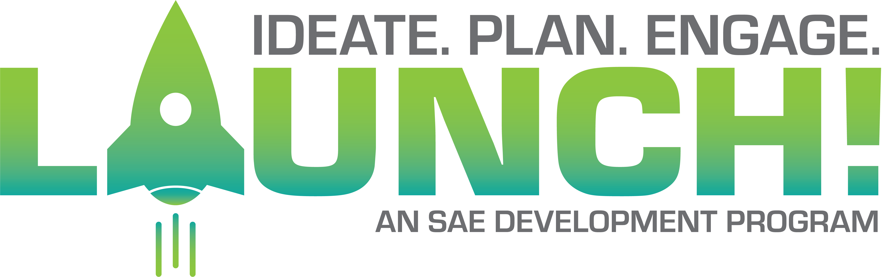

(insert date here)

Nebraska FFA Association
PO Box 95067
Lincoln, NE 68509

Dear (school name);

The Nebraska FFA Launch! program is a program designed to help schools start school-based enterprises working on a team with students and advisors. This program is to be student driven and help build entrepreneurship skills in students. This competitive program provides in person training, one-on-one coaching and significant funding for participating programs. The program will run one year in length. If selected, a program will need to ensure and send the Agricultural Education instructor and 4-6 students to each of the in-person events. These selected students are expected to manage and operate a school based enterprise.

By signing the agreement below it is a show of support for your Agricultural Education Program to apply for this exciting program.

The five in person meetings include:
Name | Location | Date | Time
Kick Off Event | Kearney Younes Center | 2-22-19 | 8:00am-6:00pm
Quick Pitch Event | TBD | Beginning of June 2019 | TBD
November Booster | TBD | Beginning of November 2019 | TBD
Wrap Up | Kearney Younes Center | February of 2020 (prior to 212/360_ | TBD
Final Pitch | Lincoln | State Convention 2020 | TBD

In addition to these five in person meetings, there will be several Zoom calls in between that students and advisors will participate in. The expectation is to have a minimum of three of the students selected at each event and Zoom call. In person meetings are required, failure to follow through on these in person meetings will result in $400.00 being returned per incident.

By signing below we understand the requirements of the Nebraska FFA Launch! program and acknowledge the fine if we miss scheduled meetings. Print and sign below and save as a pdf to load into your application

___________________ ______________________ _______________________
Chapter Advisor School Principal Chapter President

In Person Meetings Descriptions

Program Overview:
This training occurs at five training sessions held across the state (alongside or prior to other FFA events) and several Zoom calls with an Engler mentor.

Kickoff Event
Location: Kearney, Younes Conference Center (Alongside or prior to the start of 212/360 Conferences)
Time: February 23, 2019 from 8:00am-6:00pm
This event is the jumpstart to the program. Accepted programs will learn the basics of launching a school-based enterprise, explore business models, identify community needs, test business ideas, and walk away with an action plan to begin implementing.

June Quick Pitch Competition
Location: TBD, June 2019
Time: TBD
Students from participating programs will compete for seed-grant funding in a quick-pitch style competition. Students will be given five minutes to pitch the business model and implementation plans for their school-based enterprise to a panel of business and entrepreneurship judges. Programs will then gather to share best practices and further training. An additional $5,000 in funding is available at this event.

November Booster
Location: TBD (Alongside or prior to the start of P2C Conference)
Time: TBD, November 2019
At this short event programs will share progress, problem solve, and make plans for the remainder of the year. Students and teachers will also consider and craft transition plans for a new group of students to lead the enterprises.

March Wrap Up
Location: Kearney, Younes Conference Center (Alongside or prior to the start of 212/360)
Time: TBD, February 2020
At this final event, programs will provide updates and reflect on the progress of their enterprise this past year. They will have the opportunity to interact with the new cohort of programs just beginning The Nebraska FFA Launch! program. Programs will also learn the foundations of constructing a business pitch, and prepare for the Final Pitch Competition held at the State FFA Convention.

Convention Pitch Presentation
Location: Lincoln (During State Convention)
Time: TBD, During the 2020 Nebraska FFA Convention
Student teams will give a final pitch presentation to other FFA members to help encourage them to consider starting a school-based enterprise or other entrepreneurship-based SAEs during a convention workshop. Competitive awards will be provided to recognize participating students and programs in The Nebraska FFA Launch! Program. This is the conclusion of the program.

