**PLE Exemption Procedure for SY 2018-2019**

The NSLP May Update included information on the USDA policy memo SP12-2018 *Paid Lunch Equity: Guidance for School Year 2018-2019* (see attachment) which allows School Food Authorities (SFAs) with a positive or zero balance in its nonprofit food service account as of January 31, 2018 to be exempt from Paid Lunch Equity (PLE) requirements for SY 2018-2019. While SFAs that meet the criteria are exempt from the PLE requirements, SFAs have the discretion to complete the steps necessary to determine the target meal price for SY 2018-2019 and adjust their paid lunch price accordingly.  While the exemption is available to those SFAs that qualify, the decision to raise or not raise your paid lunch price should  be examined carefully. If the SFA is contributing General Funds due to a negative balance in the non-profit food service account, it would be in the SFA’s best interest to increase their paid lunch price.

The Nebraska Department of Education (NDE) **strongly encourages every** SFA to complete the PLE tool  regardless of their situation.  This will maintain the paid lunch price information in the event that the exemption is not offered for SY 2019-2020.

**NDE Procedure for Using PLE Exemption for SY 2018-19; 3 Step Process**

1. Complete the PLE Tool
2. For USDA reporting purposes, send an email now from the current Authorized Representative to [Justene.Chavez@nebraska.gov](mailto:Justene.Chavez@nebraska.gov) with the following subject line:

[Agreement Number] [SFA Name] PLE Exemption SY 2018-2019

Example: “XX-XXXX Anywhere NE School PLE Exemption SY 2018-2019”

In the body of the email include the SFA’s current Authorized Representative’s signature block (name, title, phone, etc.)

1. In July, when the online application opens up in the CNP system, attach the following:

a. Copy of the “SY 2018-19 Report” tab from the completed PLE tool

b. Copy of a profit & loss statement or balance sheet or some other financial report documenting the SFA’s zero or positive balance in the nonprofit foodservice account as of January 31, 2018.

The diagram below shows where documents can be attached within the CNP system:

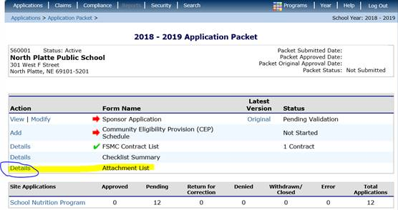

**Any SFA that does not want to increase their paid student lunch price based on the results of the 2018-2019 PLE tool will be accepted.  NDE will not send out any type of approval for this exemption.** School Meal applications for those SFAs using the PLE exemption for SY 2018-2019 will not be approved, until all three steps of the procedure are followed.  If you have questions, please contact the Nutrition Services’ office at 402-471-2488 or 800-731-2233.