Child and Adult Care Food Program (CACFP)
Online Training Modules
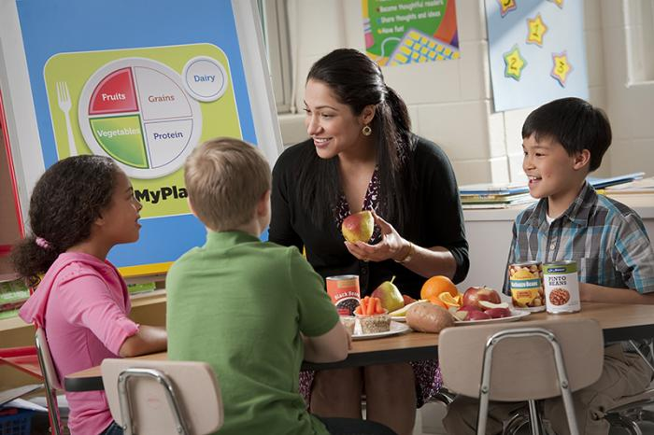
Nebraska Team Nutrition is providing additional training for CACFP centers and day care homes to support them in providing healthy, balanced meals and snacks to the children and adults they serve.
- FREE APPROVED TRAINING
- Topics covered: Whole Grain-Rich, Meats and Meat/Alternates, Milk, Fruits and Vegetables, Breakfast, Snacks, Infant Feeding, Nutrition Facts Labels, and more
- Can be completed on your own time
- Practice implementing menu changes
- Certificate upon completion of each module
Please follow the links below to access the modules developed by Team Nutrition
Contact Christy Burger with questions
cburger2@unl.edu
Nebraska Department of Education Website
https://moodle.education.ne.gov/course/index.php
Nutrition Services
Team Nutrition
CACFP

Topic | CACFP Module Objectives
Whole Grains | - Review the CACFP meal pattern requirements for grains  - Identify whole grains and whole grain rich  - Explain the benefits of whole grains  - Discuss grain based desserts and breakfast cereal sugar requirements  - Practice adding whole grain rich items into the CACFP menu
Fruit and Vegetables | - Identify the updated meal pattern requirements for fruits and vegetables  - Explain the benefits of including fruits and vegetables in CACFP menu  - Practice incorporating fruits and vegetables into meals and snacks
Milk | - Identify the updated meal pattern requirements for milk  - Describe the nutrients in milk and the benefits of milk and in the young child's diet  - Identify milk substitutions and practice incorporating milk and milk substitutions
Meat and Meat Alternates | - Review updated meat and meat alternates requirements  - Identify nutrients found in and the benefits of meats and meat alternates  - Identify different types of meat and meat alternates  - Practice incorporating meat and meat alternate and review best practices
Nutrition Facts Label | - Identify the basic information required on a food label  - Identify the new nutrition facts label  - Practice navigating the new and existing NFL; calculating serving sizes, sugar limits etc.
Snacks | - Review snack requirements for infants and children  - Learn the importance of healthy snacks and tips for introducing new foods at snack  - Discuss healthy snack ideas and practice adding healthy snacks in your CACFP menu
Breakfast | - Review the importance of breakfast and breakfast requirements for infants and children  - Review breakfast cereal and yogurt sugar limits and practice  - Explain substituting meat and meat alternates in place of grains at breakfast
Infant Meal Pattern | - Review the updated infant meal pattern and the new infant age groups  - Examine the importance of breastfeeding  - Identify developmental readiness for introducing new foods to infants  - Review the importance of working with parents on food introduction
Farm to Preschool | - Explain what is Farm to Preschool and the benefits  - Review how the new meal pattern supports Farm to Preschool and allowable expenses  - Practice using the new NDE Farm to Preschool webpage

