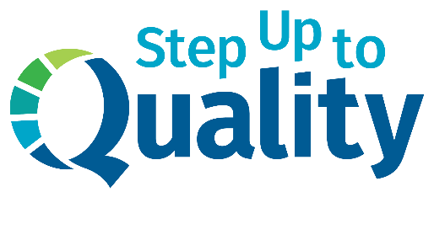
[Add your organization’s logo here]

FOR IMMEDIATE RELEASE
[Insert date]

[Insert contact name & title]
[Insert email address]
[Insert phone number]

Local early childhood organization recognized for quality child care

[Insert city, state – Insert date] – [Insert name of child care facility] has been recognized by Nebraska Step Up to Quality for its commitment to quality child care and education. Step Up to Quality programs go beyond state licensing requirements to better serve the needs of young children and their families and to prepare them for success in kindergarten and beyond.
With 90 percent of brain development occurring before age 5, early child care and education is crucial to a child’s future success. Early learning builds the foundation for skills needed in school, work and life. Studies show that children who receive quality early child care and education are more likely to show improved reading and math skills, attend college and earn higher wages.
While the majority of Nebraskans believe quality early child care is very important, only 10 percent strongly agree that young children in our state are prepared to be successful when they begin kindergarten, according to a survey conducted by Buffett Early Childhood Institute and Gallup. Parents believe their local providers could do better when it comes to quality – only 15 percent are very satisfied with the quality of programs where they live.
“It is crucial that providers and educators across the state have a mutual understanding of what quality looks like in the child care environment and that they feel supported on their path to quality,” said Lauri Cimino, director of Step Up to Quality. “Programs enrolled in Step Up to Quality have access to coaching and resources that enable any provider – big or small – to take quality to the next level.”
Step Up to Quality supports all types of early child care and education programs, including licensed family child care homes and child care centers, Head Start and Early Head Start programs, public school-operated early childhood programs and licensed preschools.
[Optional: insert quote from facility director or owner about how the program has helped you improve]

To learn more about Step Up to Quality, visit stepuptoquality.ne.gov.

###

Step Up to Quality is the state of Nebraska’s Quality Rating and Improvement System (QRIS). A QRIS helps states assess, improve and communicate the level of quality of early childhood programs. Programs are awarded quality ratings for meeting a defined set of program standards. Step Up to Quality is voluntary for most early childhood programs. Programs who receive more than $250,000 in child care subsidies are required to participate. Step Up to Quality is funded through the Nebraska Department of Education and Department of Health and Human Services.

