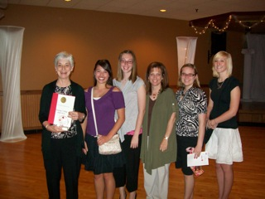
Central Plains Red Cross Supporting Academics – PHIVE-O’s and Sunny D’s
The Sunny D’s and PHIVE-O’s are youth groups who focus on peer education on HIV/AIDS in the central Nebraska area. The PHIVE-O’s began in 1991, 20 years ago, thru the Hastings College, making sure that every incoming student hears at least one hour of HIV prevention information from them. The Sunny D’s began in 1997 thru juniors and seniors in Hastings High School. These groups work diligently to raise awareness and educate about a serious and difficult topic. Led by Judy Sandeen and Chris Junker, these youth make a difference every day in the lives of our youth.
Thank you all for your help in presenting a tough topic thru peer education!
Pictured are Judy Sandeen, Hailey Hemenway, Kelley Junker, Chris Junker, Jaime DeTour and Liz Sullivan, PHIVE-O and Sunny “D’s” sponsors and members.

