

Cherrie Kerr & Terri Jelinek

Strand: GEOMETRY

Grade Levels – 9-12

Disney World has contacted Conductix Wampfler to construct power rails for their Monorail system. Conductix Wampfler makes rails in 30 feet sections and the radius of the curve needs to be 150 feet. The rails are constructed as straight segments and need to be slowly bent to the correct curvature. Since workers cannot physically measure this large of a radius they draw a chord connecting the endpoints of the rail. They then measure the distance to the chord from the midpoint of the arc to determine when they have achieved the correct curvature. What is the correct length (chord height) the workers should measure from the midpoint of the chord to the midpoint of the arc?

Arc length BC is 30 feet. Radii AB and AC are 150 feet.

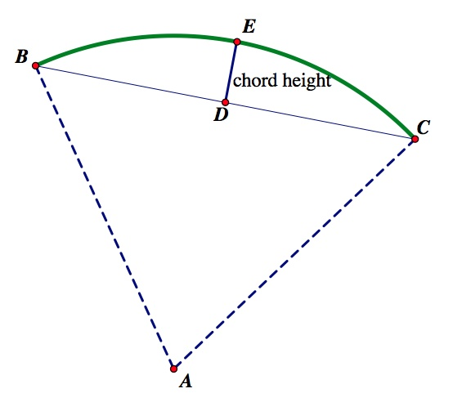

Teacher Notes

**Vocabulary –**

**Chord height –** refers to the distance from the midpoint of the arc to the midpoint of the chord. Segment DE on our diagram.

Step 1) Calculate the measure of angle A. Formula: Arc length = $\frac{angle}{360°}$ • 2πr

30 = $\frac{angle}{360°}$• 2π•150 angle = 11.459°

Step 2) Bisect angle A to create a right triangle. 11.459÷2 = 5.7296°

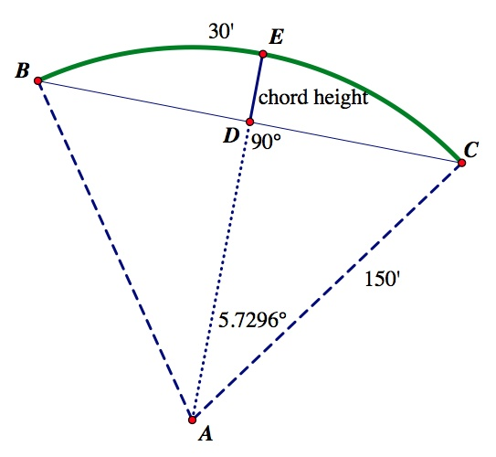

Step 3) Use trig to find AD. Cos(5.7296°) = $\frac{AD}{150}$ AD = 149.2506 feet

Step 4) Since AE is a radius of 150 feet, take 150 – 149.2506 = 0.7494 feet or 8.9928 (approximately 9 inches).



Courtney Beach and Doug Glasshoff

Strand: NUMBER

Grade Level: 6-8

**Problem 4 Student Page**

**Resource Request based on Project Timeline**

We are looking to convert 225 clients from solution 1 to solution 2. We know that the average implementation requires 4 resource days to complete the conversion. There are currently 13 employees within the implementation team of which 5 are available for these conversions.

a.) How long will it take the 5 employees to complete the conversion project?

b.) If management would like the project to be completed in 60 business days would additional resources be needed? If so, how many?

c.) If management approves hiring 4 additional resources how long will it take to complete the conversion project?



**Teacher Page**

**Student Vocabulary**

Solutions – computer software

Implementation – downloading the software on all bank computers

Clients – banks buying the software

Resource days – work days Monday through Friday

**Optional Scaffolding Questions for Students**

Identify irrelevant information.

How many resource days are needed to convert all 225 clients?

Split the total workload by all the available workers.

**Solution:**

a.) Total Resource Days Needed:  resource days needed

Total Days it will take team:  days for the 5 team members

Total Months based on 20-day work months:  months

b.) Employees needed to split the work to get it done in 60 days: 

 people

Additional resources:  additional people needed

c.) New number of employees working on the project:  people

Number of days it would take the team to complete the project:  days



Deb Bulin, Cody Franzen, Sandi Snyder

Strand: GEOMETRY

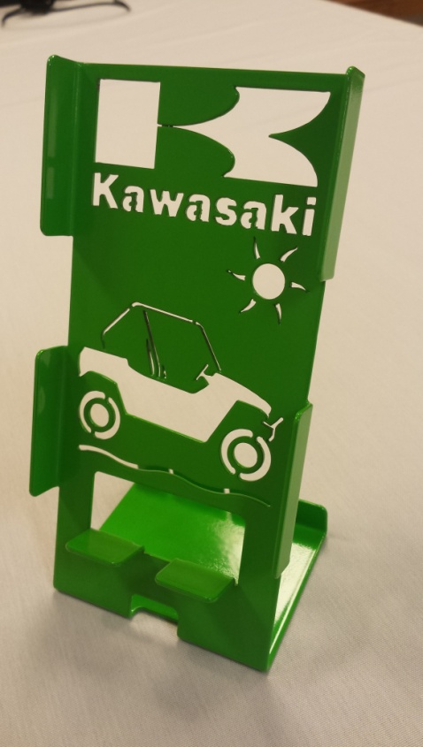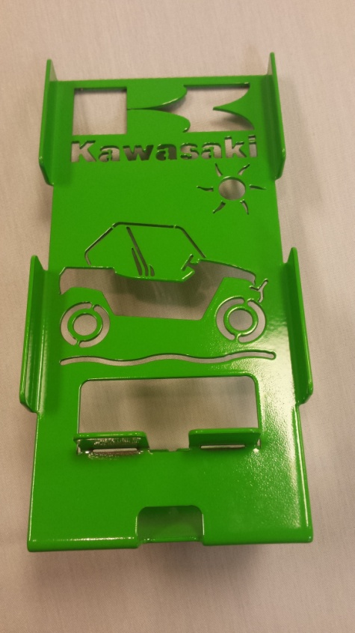Grades: 6-8 and 9-12

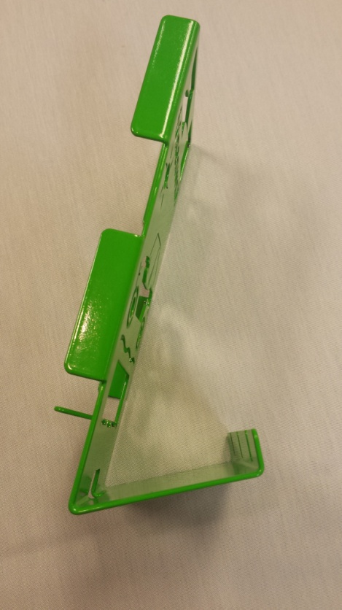

Draw an accurate net for the cell-phone holder.

If the metal comes in sheets that are 10 feet by 6 feet, how many cell phone holders could the laser cutter cut out from one sheet of metal? How much waste is there? Show all calculations used to get your answer. Assume that there is 3 mm between each shape and the laser leaves at least 3 mm on each edge.



Teacher Page

You could have this be as accurate as you want it to be. You could just have the basic rectangle or look at some of the other cut outs. You could even have them estimate the graphics ☺

8.5 cm



5 cm

1.4 cm

17.6 cm

6 cm

1.4 cm

We got approximately 180 units could be cut out.



LINCOLN MACHINE

Ben Welsch, Jill Krienke, Phyllis Severson

STRAND – ALGEBRA

Grade Level – HS

Mathematical Processes – Modeling, Communication, & Connections

Problem #2

Paul comes to your machinist shop and needs 5,000 ellipse shaped washers to use in his fencing business. He wants to know how much it will cost and how long it will take. What cost and time options do you give Paul to complete his order? Each workday at your machinist shop is 8 hours.

A mold needs to be created to fabricate each ellipse washer. Each mold takes 30 minutes to make and costs $15. Once the molds are created, each washer takes 4 minutes to set and costs 35 cents.



TEACHER NOTES:

How many molds do I need to make?

* cost $15 per mold
* time is 30 minutes per mold

(16 molds per day = $240)

How fast can I make the washers with *x* molds?

* 15 washers per mold per hour

($1,750 for 5,000 washers)

Students can trade answers to pick which option is best (Time vs. Money)

Sample Answers:

|  |  |  |  |
| --- | --- | --- | --- |
| 32 molds | 24 molds | 16 molds | 8 molds |
| $2230 | $2110 | $1990 | $1870 |
| 26.5 hours | 26 hours | 29 hours | 46 hours |



Kris Linder, Stephanie Buzek, Jim Harrington

Strand: GEOMETRY/ALGEBRA (reading tables)

Grade: High School

**Student Problem**

Given the information in the following diagrams, approximate the volume of steel needed to build the light pole base.

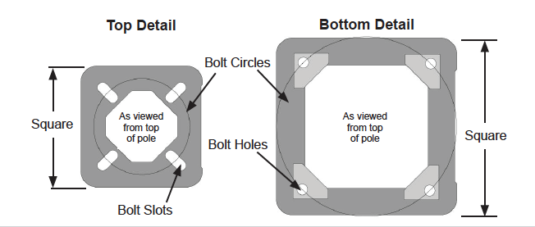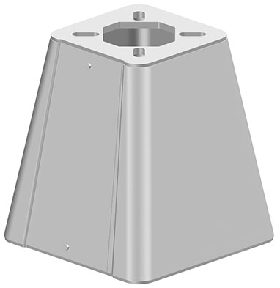

Assume that the area cut out of the top plate is an inscribed square.

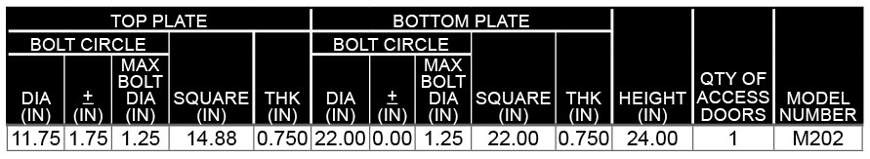



**Teacher Page**

Volume of top plate: $\left({14.882}^{2}-{11.75}^{2}÷2\right)×0.75$ = 114.287 in3

Volume of bottom plate: 181.5 in3

Volume of 4 trapezoids: = 1,947.338 in3

Total Volume: 114.287 + 181.5 + 1947.388 = 2,243.125 in3